

COMSATS University Islamabad, Pakistan

M2B (Mother to Be)

A project presented to
COMSATS Institute of Information Technology, Islamabad

In partial fulfilment
of the requirements for the degree of

Bachelor of Science in Computer Science (2022-2026)

By

Muhammad Tayyab CIIT/SP22-BCS-168/SWL
Sarfraz Ahmed Awaisi CIIT/SP22-BCS-157/SWL
Muhammad Umar CIIT/SP22-BCS-159/SWL

Declaration
We hereby declare that this project titled “M2B” is the result of our own work and effort. This project has not been submitted, wholly or partially, for the award of any degree or diploma in this or any other institute or university.
We further declare that no part of this project has been copied from any source except where due reference is given. If any part of this work is found to be copied or reproduced without citation, we shall be responsible for the consequences.
All development, documentation, design, and results presented in this report are based on our personal efforts and understanding throughout the Final Year Project duration.

Muhammad Tayyab Sarfraz Ahmed Muhammad Umar

Certificate of Approval
It is to certify that the final year project of BS (CS) “M2B” was developed by Sarfraz Ahmed Awaisi (CIIT/SP22-BCS-157/SWL), Muhammad Tayyab (CIIT/SP22-BCS-168/SWL) and Muhammad Umar (CIIT/SP22-BCS-159/SWL) under the supervision of “Dr. Yawar Abbas Abid” and co-supervisor “Mr. Ali Sher Kashif” and that in their opinion, it is fully adequate, in scope and quality for the degree of Bachelor of Science in Computer Sciences.

Supervisor

Dr. Yawar Abbas Abid

External Examiner

Head of Department
Dr. Zafar Iqbal Roy

Executive Summary
Maternal healthcare remains one of the most important domains requiring technological intervention. In many developing regions, pregnant women struggle to maintain organized medical records and lack direct access to certified doctors for timely consultation. Existing digital solutions often focus only on basic tracking, while communication with healthcare professionals remains fragmented.
To address these challenges, this project introduces a Prenatal Health Monitoring and Management System, a mobile application designed specifically for pregnant women. The system replaces the need for smartwatch integration and instead allows complete manual entry of health data, including blood pressure, heart rate, weight, symptoms, and daily observations.
Patients can subscribe to doctors for monthly consultation, enabling doctors to view patient records, monitor trends, and provide personalized recommendations. The system includes a secure chat interface, subscription workflow, and role-based access for patient, doctor. Firebase is used as the backend for authentication, real-time database operations, and storage.
This project provides a centralized, reliable, and secure platform that improves prenatal care by enabling accurate health tracking, organized medical history, and seamless patient-doctor communication

Acknowledgment
We express our sincere gratitude to Almighty Allah for giving us the strength, patience, and knowledge to complete this project successfully.
We would like to thank our supervisor Dr. Yawar Abbas Abid and co-supervisor Mr. Ali Sher Kashif for their continuous guidance, motivation, and valuable suggestions throughout the development process. Their experience and support played a vital role in shaping the direction of this project.
We are also thankful to our families and friends for their encouragement, moral support, and prayers during the entire duration of our degree.
Finally, we appreciate all faculty members and the Department of Computer Science at COMSATS University Islamabad, Sahiwal Campus, for providing us with the skills and academic foundation needed to accomplish this project.

Muhammad Tayyab Sarfraz Ahmed Muhammad Umar

Abbreviations

SRS | Software Require Specification
PC | Personal Computer
UI | User Interface
UX | User Experience
FYP | Final Year Project
SDLC | Software Development Life Cycle
SQL | Structured Query Language
API | Application Programming Interface
DBMS | Database Management System

Contents
1. Introduction 1
1.1 Brief 1
1.2 Relevance to Course Modules 2
1.3 Project Background 4
1.4 Literature Review 5
1.5 Analysis from Literature Review 6
1.6 Methodology and Software Lifecycle for This Project 7
1.6.1 Rationale Behind Selected Methodology 8
1.7. Extended Background 9
1.8. Extended Literature Review 10
2. Problem 13
2.1 Problem Statement 13
2.2. Deliverables and Development Requirements 14
2.2.1 Project Deliverables 14
2.3 Current System 16
2.3.1 Wearable-dependent Systems 16
2.3.2 Lack of Doctor–Patient Communication 16
2.3.3 No Centralized Monitoring 17
2.3.4 Data Privacy Issues 17
2.4 Need for the Proposed System 17
3. Requirements Analysis 19
3.1 Use Case Diagram(s) 19
3.2 Detailed Use Cases 20
3.3 Functional Requirements 25
3.3.1 Patient Module Functional Requirements 26
3.3.2 Doctor Module Functional Requirements 27
3.4 Non-Functional Requirements 27
3.4.1 Usability Requirements 28
3.4.2 Security Requirements 28
3.4.3 Performance Requirements 28
3.4.4 Reliability Requirements 28
3.4.5 Scalability Requirements 28
3.4.6 Compatibility Requirements 28
3.4.7 Maintainability Requirements 28
3.4.8 Availability Requirements 28
3.4.9 Data Integrity Requirements 29
4. Design and Architecture 31
4.1 System Architecture 31
4.1.1. Extended Architecture Explanation 34
4.2 Data Representation 36
4.3 Process Flow / Representation 38
4.4 Design Models 41
4.4.1 Use Case Model 41
4.4.2 Sequence Model 42
4.4.3 Class Model 43
4.4.4 Architectural Model 44
5. Implementation 46
5.1 Implementation Overview 46
5.2 External APIs & Technologies Used 47
5.3 Patient Application Implementation 49
5.3.1 Login & Registration 49
5.3.2 Manual Health Data Entry 52
5.3.3 Health History View 54
5.3.4 Doctor Search and View 58
5.3.5 Subscription System 60
5.3.6 Chat Module 62
5.4 Doctor Application Implementation 64
5.4.1 Doctor Login & Profile Setup 64
5.4.2 Subscribed Patient List 67
5.4.3 Viewing Manual Health Data 69
5.4.4 Writing Recommendations 71
5.4.5 Chat Module 71
5.5 User Interface Design 73
6. Testing and Evaluation 79
6.1 Manual Testing 79
6.1.1 System Testing 80
6.1.2 Unit Testing 80
6.1.3 Functional Testing 81
6.1.4 Integration Testing 82
6.2 Automated Testing 83
Tools Used 84
7. Conclusion and Future Work 87
7.1 Conclusion 87
7.2 Future Work 88
8. References 92

List of Figures

Figure 4.1.1 System Architecture 26
Figure 4.2.1 Data Representation/ERD 28
Figure 4.3.1 Process Flow 30
Figure 4.4.1 Use Case Diagram 31
Figure 4.4.2 Sequence Diagram 32
Figure 4.4.3 Class Diagram 33
Figure 4.4.4 Architectural Model 33
Figure 5.3.1 Registration Screen 38
Figure 5.3.2 Login Screen 39
Figure 5.3.3 Manual Health Data Entry 41
Figure 5.3.4 Health History View 43
Figure 5.3.5 Health History Review 44
Figure 5.3.6 Health History View 45
Figure 5.3.7 Doctor Search & View 47
Figure 5.3.8 Subscription Screen 49
Figure 5.3.9 Chat Module 51
Figure 5.3.10 Doctor Signup Screen 53
Figure 5.3.11 Doctor Login Screen 54
Figure 5.3.12 Subscribed Patient Lists 56
Figure 5.3.13 Manual Health Data 58
Figure 5.3.14 Chat Module 60
Figure 5.3.15 Patient UI 62
Figure 5.3.16 Doctor UI 64

List of Tables
Table 1 User Authentication 16
Table 2 Manage Patient Profile 16
Table 3 Manual Health Data Entry 17
Table 4 View Health Records 17
Table 5 Search and View Doctors 17
Table 6 Subscribe to Doctor 18
Table 7 Provide Treatment Recommendations 18
Table 8 Chat System 18
Table 9 Logout 19
Table 10 External APIs 64
Table 11 System Testing 68
Table 12 Unit Testing 68
Table 13 Functional Testing 69
Table 14 Integration Testing 69
Table 15 Automated Testing 70

Chapter 1
Introduction

1. Introduction
Pregnancy is a transformative period in a woman’s life and requires continuous observation, timely guidance, and reliable communication with healthcare professionals. However, in many regions, women face numerous barriers that limit their ability to receive consistent prenatal care. These include distance from clinics, transport difficulties, time constraints, financial limitations, or simply a lack of awareness about which symptoms require medical attention. Traditionally, pregnant women rely on periodic clinical visits and verbal communication to report their symptoms. This creates significant gaps because symptoms may occur suddenly, change frequently, or be forgotten by the time of the next appointment.
The M2B (Mother to Baby) system addresses these challenges by offering a convenient mobile-based platform for pregnant women to manually record their daily health indicators, symptoms, and concerns. This daily logging approach ensures that no critical information is missed and allows doctors to view a complete, accurate, and time-based health record. Even when patients do not have access to wearable devices, the manual-input method ensures inclusivity while still providing meaningful data to the doctor for decision-making.
The system also bridges the communication gap between mothers and healthcare providers by enabling real-time chat and digital recommendations. Instead of waiting for the next clinical visit, patients can reach out through the app and receive timely guidance, which is especially important when dealing with early warning signs. By combining manual data input with doctor supervision, M2B contributes to safer pregnancies, early detection of complications, and enhanced maternal well-being.

1.1 Brief
The M2B system is designed as a mobile-based prenatal support solution, enabling pregnant women to monitor their daily symptoms, track essential health parameters, and receive medical guidance without the need for physical visits. It bridges the communication gap between patients and healthcare providers by allowing real-time chat, data sharing, and recommendation exchange. The system provides a structured and organized method for women to record their health information, which doctors can easily review to make accurate clinical decisions.
The brief purpose of this project is to empower expecting mothers with an easy-to-use digital tool that supports early detection of complications, enhances self-awareness, and ensures timely doctor engagement. By relying on manual data entry, the system ensures that even users without wearable devices can participate in digital health monitoring.
- Blood Pressure
- Heart rate
- Weight
- Symptoms
- Mood and physical condition
- Fetal movement
- Daily medical observations

It offers:
- A simple way for mothers to track daily health
- Direct access to doctors for real-time recommendations
- A secure in-app chat system
- A subscription-based doctor consultation model
- A centralized medical record accessible anytime
Developed using Flutter and Firebase, the system ensures reliability, security, and cross-platform compatibility.

1.2 Relevance to Course Modules
This project aligns with various modules studied throughout the degree program, such as Mobile Application Development, Software Engineering, Requirements Engineering, Database Systems, and Human-Computer Interaction. The practical implementation of Flutter for cross-platform mobile development directly applies knowledge gained in mobile computing courses.

Similarly, concepts from Software Engineering and Requirements Engineering are applied in designing the system architecture, defining functional and non-functional requirements, developing use cases, and following a structured development lifecycle. The integration of Firebase services demonstrates real-world application of cloud databases, authentication systems, and backend integration taught in database and distributed system modules. Human-Computer Interaction principles are applied when designing a simple and empathetic interface tailored for pregnant women.
Relevant Courses and Their Contribution
- Software Engineering
Contributed the foundation for requirements gathering, SRS writing, system design, SDLC selection, and architectural documentation.
- Mobile Application Development
Enabled the development of the cross-platform mobile application using Flutter.
- Database Systems
Provided knowledge of data modeling, Firestore database design, structured and unstructured data handling, indexing, and querying techniques.
- Human Computer Interaction (HCI)
Guided UI/UX considerations, usability principles, layout planning, form validation, and accessibility features for pregnant women.
- Object Oriented Programming
Provided the ability to design reusable components, classes, objects, and interactions across modules.
- Information Security
Guided the authentication design, data encryption, role-based access control, and secure communication between users and doctors.
- Data Structures & Algorithms
Helped optimize data handling, retrieval, filtering, and timeline-based health tracking.
The project, therefore, demonstrates a comprehensive application of course concepts and successfully integrates multiple domains of computer science.

1.3 Project Background
Prenatal care traditionally relies on scheduled clinical visits, where doctors evaluate the patient based on the symptoms she recalls. However, many symptoms such as dizziness, abnormal fetal movements, or fluctuating blood pressure may occur unpredictably and may not be remembered accurately. This often leads to incomplete assessments and delayed diagnosis of complications. A digital solution that allows patients to record changes as they occur can significantly improve the quality of care they receive.
In rural areas or low-income regions, limited access to hospitals and medical professionals worsens this problem. Women may skip checkups due to travel difficulties, lack of support, or financial barriers. M2B is designed to overcome these limitations by bringing prenatal tracking and communication directly to mobile devices. By allowing mothers to store daily observations, the system builds a comprehensive health history that remains available to both the patient and her doctor at all times.
- Limited access to healthcare facilities
- Long travel distances
- Lack of awareness or follow-up
- Overcrowded hospitals
- Time restrictions for frequent visits
- Poor continuity between checkups
Traditional health monitoring systems rely heavily on in-person visits, making it difficult for women to maintain regular communication with their doctors.
With the increasing use of smartphones, digital health solutions have become an effective way to bridge this gap. Mobile health (mHealth) applications offer convenience, real-time communication, and improved patient engagement.
Most existing applications rely on wearable devices such as smartwatches to gather real-time data. However, these devices are expensive, require technical understanding, and are not accessible to a large portion of the population.

Gap in Existing Systems
- Wearable-based apps are costly and not user-friendly for all mothers.
- Many existing apps do not allow doctor consultation directly.
- Data storage is often not secure or lacks proper medical structuring.
- Manual-entry based prenatal systems with doctor connectivity are still limited.
This project fills this gap by providing a manual data-entry prenatal monitoring app, ensuring:
- Accessibility
- Simplicity
- Medical relevance
- Real-time doctor supervision through chat
- Affordable and scalable design

1.4 Literature Review
Existing maternal health applications focus largely on educational content or rely on wearable devices to automate data collection. While educational content is helpful, it does not replace the need for continuous monitoring and doctor interaction. Wearable-based systems provide excellent tracking but are often expensive and inaccessible for many women in developing regions. Research also highlights that inconsistent communication between mothers and doctors leads to delayed interventions, which increases risks during pregnancy. [1]
Several studies emphasize that self-monitoring significantly improves maternal awareness and leads to early detection of complications such as gestational diabetes, hypertension, and anemia. Research on mobile health (mHealth) interventions also shows that digital platforms improve adherence to medical advice, increase follow-up compliance, and reduce anxiety among pregnant women. The literature reveals a clear gap: many solutions either offer self-tracking without professional supervision or doctor services without systematic symptom recording. M2B aims to bridge both gaps.

Studies on Prenatal Health Monitoring
Research shows that continuous tracking of prenatal metrics significantly reduces maternal risks. Studies highlight that:
- Early detection of abnormalities (e.g., high blood pressure, abnormal heart rate) reduces pregnancy complications.
- Structured daily symptom logs increase doctor awareness and intervention ability.
- Remote health monitoring reduces hospital burden and improves care outcomes.

Mobile Health Applications
Health applications have become popular due to:
- Ubiquity of smartphones
- Ease of distribution
- Automated alerts and reminders
- Patient empowerment through self-monitoring
However, these apps often lack:
- Supervised medical review
- Secure data handling
- Affordable manual entry systems
Doctor–Patient Digital Communication
Digital consultations improve:
- Speed of response
- Convenience
- Monitoring of high-risk pregnancies
- Data-driven decision-making
But many apps suffer from fragmented communication, lack of structured health records, and limited medical integration.

1.5 Analysis from Literature Review
Existing maternal health applications focus largely on educational content or rely on wearable devices to automate data collection. While educational content is helpful, it does not replace the need for continuous monitoring and doctor interaction. Wearable-based systems provide excellent tracking but are often expensive and inaccessible for many women in developing regions. Research also highlights that inconsistent communication between mothers and doctors leads to delayed interventions, which increases risks during pregnancy.
Several studies emphasize that self-monitoring significantly improves maternal awareness and leads to early detection of complications such as gestational diabetes, hypertension, and anemia. Research on mobile health (mHealth) interventions also shows that digital platforms improve adherence to medical advice, increase follow-up compliance, and reduce anxiety among pregnant women. The literature reveals a clear gap: many solutions either offer self-tracking without professional supervision or doctor services without systematic symptom recording. M2B aims to bridge both gaps. [2]
Based on the reviewed studies and technologies:
- Continuous prenatal monitoring is necessary.
- Data should be structured, medically relevant, and easy to input manually.
- Doctor supervision must be reliable and integrated.
- Existing smartwatch-based systems create financial and accessibility barriers.
This project's manual-entry model directly addresses these limitations by:
- Eliminating the dependency on wearables
- Making the system inclusive for all demographics
- Providing real-time communication with doctors
- Supporting structured medical records
Thus, the proposed solution fits well into the current healthcare technology landscape while providing improvements over existing systems.

1.6 Methodology and Software Lifecycle for This Project
The development of M2B follows an incremental and iterative software lifecycle. Each module, such as patient data entry, doctor recommendations, chat, and subscription features, was developed individually and then integrated. This approach allowed the team to gather feedback during development, make improvements early, and ensure that the final system aligns with user needs.
Choosing an iterative lifecycle also ensured that the system remained flexible. As new requirements emerged, adjustments could be made without disrupting existing functionality. This aligns with modern software practices that value adaptability, continuous improvement, and modular development.
The Agile Software Development Life Cycle (SDLC) model was selected for this project. Agile enables iterative development, continuous feedback, and flexibility—ideal for applications that require UI refinement, doctor interaction design, and evolving feature sets.
Justification for Agile SDLC
- Requirements may evolve based on doctor feedback.
- UI improvements need continuous iteration, especially for pregnant users.
- Agile enables rapid prototyping and testing of features like chat, subscription, and manual entry forms.
- Firebase integration benefits from incremental updates.
- Ensures faster delivery and consistent evaluation.

1.6.1 Rationale Behind Selected Methodology
The chosen methodology supports gradual refinement of the system, making it easier to test, review, and enhance specific components. Since the project required frequent interaction with Firebase, an iterative approach simplified integration and debugging. The evolving nature of user requirements during development also made it necessary to use a model that supports continuous feedback. The methodology ensures that the final system is stable, user-friendly, and aligned with the practical expectations of both patients and doctors.

Agile was chosen because:
- The project benefits from short development cycles (sprints).
- Frequent UI/UX testing is required to ensure ease of use.
- Manual data entry workflows require iterative refinement.
- It enhances collaboration and reduces risk.
Agile adaptability makes it the most suitable choice for developing and deploying a user–doctor-centered health monitoring system.

1.7. Extended Background
Pregnancy is a period that requires continuous observation, careful monitoring, and ongoing communication between a patient and her doctor. Historically, prenatal care relied heavily on physical visits to clinics, where symptoms and concerns were often remembered subjectively rather than documented consistently. In many countries, especially in developing regions, this model remains the dominant form of care. However, it creates several gaps for expecting mothers.
One major challenge during pregnancy is the unpredictability of symptoms. A patient might feel discomfort at home, experience sudden changes in blood pressure, or notice unusual fetal movements. In many such situations, she may need immediate medical guidance, but reaching the clinic becomes difficult due to mobility issues, financial constraints, or transportation problems. Moreover, hospitals often deal with long queues, crowded waiting areas, and overloaded obstetric units, which discourage regular checkups.
Digital solutions have started to bridge this gap. Mobile health applications have become increasingly popular because they provide accessible and structured health tracking. However, most modern prenatal apps assume the availability of wearable devices such as smartwatches, heart rate monitors, or fitness bands. While these devices simplify health tracking, they are often expensive and inaccessible to lower-income populations. This creates a divide: those who can afford digital gadgets enjoy better monitoring, while others rely on limited traditional care.
In Pakistan and similar regions, a large majority of families live without wearable devices. Therefore, a manual-entry-based prenatal monitoring system becomes far more practical and inclusive. Such a system does not require additional hardware; instead, it enables any pregnant woman with a smartphone to document her health symptoms accurately and share them with doctors for timely evaluation.
The significance of structured data becomes clear when reviewing common pregnancy complications such as gestational hypertension, gestational diabetes, anemia, and preeclampsia. Early identification of abnormal patterns in blood pressure, weight, or symptoms can prevent serious outcomes. A manual-entry system ensures that even without advanced hardware, women remain empowered to track their pregnancy journey and receive medical advice based on their own records.

1.8. Extended Literature Review
The adoption of mobile health (mHealth) technologies has grown rapidly across the globe. Researchers highlight that digital tools enhance accessibility and strengthen the monitoring process during pregnancy. For instance, numerous studies indicate that consistent tracking of vital signs and symptoms significantly improves maternal health outcomes, particularly in high-risk pregnancies.
A study on maternal monitoring systems showed that women who used mobile apps were more likely to recognize danger signs early, such as abnormal swelling, headaches, dizziness, or bleeding. The structured format of digital entry allows patients to reflect on their condition and communicate symptoms more precisely during doctor consultations.
Another area of research studies prenatal telemedicine. Telemedicine platforms enable remote consultations and allow women to receive professional guidance without physically visiting clinics. This has proven especially beneficial for rural or geographically isolated communities. During the COVID-19 pandemic, telemedicine became a primary channel for prenatal checkups worldwide, reinforcing its importance in the healthcare ecosystem.
Existing mobile applications, such as Ovia Pregnancy, Pregnancy+, and Glow, offer symptom tracking and educational content. However, most of these applications are focused on general pregnancy guidance rather than doctor-supervised monitoring. They also lack culturally relevant design for regions like Pakistan and often require premium subscriptions for advanced features. Furthermore, many global apps are designed to integrate with wearables, limiting their accessibility.
Academic research also emphasizes the importance of communication between doctors and patients. Research from WHO demonstrates that digital interventions improve the doctor–patient relationship by ensuring timely communication, reducing hospital burden, and enabling proactive care. Mobile platforms allow for continuous monitoring, where doctors can observe the patient’s history before providing tailored recommendations.

However, literature also identifies key limitations in existing digital maternal health solutions:
- Lack of direct doctor–patient interaction
- Limited reliability due to self-diagnosis
- Poor data organization
- Dependence on wearable devices
- Lack of local medical context
This gap in research supports the development of a manual-entry, doctor-supervised prenatal app such as M2B. It addresses the limitations by incorporating doctor recommendations, structured data entry, local relevance, and real-time communication.

Chapter 2
Problem Definition

2. Problem
Maternal health remains a significant challenge, particularly in communities where healthcare access is inconsistent or limited. Many pregnant women struggle to maintain consistent communication with their doctors due to distance, financial constraints, or hospital overcrowding. As a result, health issues that begin as mild symptoms may escalate into complications if they are not monitored correctly. The traditional system depends heavily on scheduled visits and verbal symptom descriptions, which often leads to incomplete information sharing. Recognizing these gaps, the M2B system aims to provide a digital bridge that helps mothers document their health in real-time while enabling doctors to monitor and respond appropriately.

2.1 Problem Statement
Pregnant women lack a reliable, continuous, and affordable method to track daily health symptoms and share them with healthcare professionals. Wearable devices are expensive, and most existing digital solutions rely on automated data collection through such hardware. This creates a barrier for many women in low-resource environments. Additionally, current systems provide limited interaction between patients and doctors, making it difficult to detect early warning signs of pregnancy-related complications. There is a need for a system that allows for manual entry of health data, seamless communication, and personalized doctor feedback — all in a single platform accessible on any smartphone. [3]
Pregnancy requires continuous health monitoring, timely doctor communication, and regular logging of medical symptoms. However, many pregnant women face significant challenges:
- Limited access to healthcare facilities
- Difficulty in maintaining regular hospital visits
- Lack of structured daily monitoring
- No continuous doctor supervision outside appointments
- Expensive or inaccessible wearable devices
- Inability to maintain accurate symptom records
- Poor follow-up due to financial, geographic, or personal constraints
Most existing health-monitoring applications rely on smartwatch integration or automated data capture, which makes them costly and inaccessible to the majority of patients—especially in low-income or rural regions. Additionally, many systems do not offer direct doctor consultation or secure medical record handling.
Therefore, there is a need for an affordable, secure, and accessible mobile solution where pregnant women can manually enter their health data and receive timely doctor supervision.
The proposed system resolves this by enabling patients to manually log vital health information and communicate with doctors through a subscription-based platform using a mobile application.

2.2. Deliverables and Development Requirements
The project requires the delivery of a mobile application that supports manual health data entry, patient–doctor communication, doctor recommendations, and a secure system to store and access data. These deliverables must ensure that the application is user-friendly and operates smoothly even on devices with limited resources. The development also demands a scalable backend capable of handling multiple users simultaneously and maintaining data accuracy and security. Additionally, thorough testing must be performed to verify that all modules work correctly under different conditions, including slow internet, data load variations, and real-time chat communication.
The main deliverables of the Prenatal Health Monitoring & Doctor Consultation System include:

2.2.1 Project Deliverables
The deliverables include a fully functional patient application where mothers can record and review their health entries, search for doctors, subscribe to a chosen doctor, and receive medical guidance. A doctor-side application must also be delivered, allowing healthcare professionals to review the data submitted by patients, send recommendations, and communicate when needed. The backend deliverables include a structured Firebase database setup, secure authentication system, and real-time sync modules for chat and data sharing. Additional documentation such as the Software Requirements Specification (SRS), design diagrams, testing reports, and the final project report are also part of the deliverables.
- Mobile Application (Flutter-based)
  - Patient module (manual data entry, health tracking, profile)
  - Doctor module (patient access, recommendations, chat)
  - Secure authentication
  - Subscription workflow
  - Real-time chat system
- Backend System (Firebase)
  - Firestore Database / Realtime DB
  - Secure login and registration
  - Encrypted data storage
  - Role-based access control
  - Cloud storage for patient history and documents
- Manual Data Entry Module
  - Completely replaces smartwatch auto-sync
  - Structured and validated forms for medical metrics
- Doctor Recommendation System
  - Doctors can view patient entries
  - Write medical advice and follow-up recommendations
- Project Documentation
  - SRS
  - SDD
  - Final Year Project Report
  - Testing and Evaluation report

2.3 Current System
The current prenatal monitoring system relies heavily on periodic clinic visits where patients tell doctors their symptoms. This approach is prone to omissions because mothers may forget to mention certain symptoms or misunderstand their importance. Additionally, clinics often remain overcrowded, causing delays in diagnosis and limiting the amount of time doctors can spend with each patient. Physical records are difficult to maintain, and many women lack structured documentation of their health between checkups. This results in incomplete clinical evaluation and increases the risk of undetected complications. [4]

2.3.1 Wearable-dependent Systems
Many modern solutions rely on wearable devices to automate health tracking. While efficient, these systems are not affordable or accessible for a large population segment. Wearables also require technical understanding, maintenance, and regular charging, which many users find inconvenient. Furthermore, wearable-based solutions often focus only on data collection and ignore the need for personalized medical support. They do not provide structured interaction between the patient and doctor. As a result, there is an urgent need for a simpler, more inclusive solution that replicates the benefits of modern systems without requiring expensive gadgets.
Many existing solutions depend on smartwatches or sensors for collecting data. These systems:
- Require expensive devices
- Are difficult for non-technical users
- Depend on Bluetooth or external APIs
- Are not accessible in low-income communities

2.3.2 Lack of Doctor–Patient Communication
Traditional prenatal care relies on:
- In-person visits
- Long intervals between checkups
- Paper-based health record tracking

This results in:
- Missed early warning signs
- Inability to save or share daily symptoms
- No real-time doctor engagement

2.3.3 No Centralized Monitoring
There is no consistent method for:
- Tracking daily vitals
- Comparing trends
- Allowing doctors to remotely monitor patients
- Maintaining a unified, secure medical record

2.3.4 Data Privacy Issues
Many mobile apps lack proper:
- Encryption
- Secure authentication
- Role-based access
- Medical record protection

2.4 Need for the Proposed System
The proposed system solves these problems by offering:
- Manual health data entry, removing dependency on expensive devices
- Direct doctor supervision through subscription
- Real-time chat system for instant communication
- Secure and centralized medical records
- Easy-to-use UI for pregnant women
- Admin oversight to ensure system transparency

Chapter 3
Requirement Analysis

3. Requirements Analysis
A thorough requirement analysis ensures that the system aligns with user expectations and addresses the real challenges faced by pregnant women and healthcare providers. Since prenatal care involves many unpredictable changes, the system must be designed to capture accurate and complete information through simple and intuitive processes. Understanding what users need, how they will interact with the application, and what outcomes they expect helps create a solution that is not only functional but genuinely supportive in real-life scenarios. The requirement analysis also bridges the communication gap between technical design teams and medical professionals, ensuring that the final system reflects both technical feasibility and clinical relevance.
This chapter presents a complete analysis of the system’s requirements. It includes requirement identification techniques, use case diagrams, user classes, detailed use cases, functional and non-functional requirements, system constraints, and assumptions.
The primary goal of the M2B – Mother-to-Be Prenatal Health Monitoring & Management System is to enable pregnant women to manually track their vitals and allow doctors to monitor patients through a subscription-based model.

3.1 Use Case Diagram(s)
The use case diagrams represent the roles and interactions within the system. They illustrate how patients, doctors, and various system components communicate with one another. These diagrams help break down the system into smaller, understandable segments, making it easier to validate that each required function is included. By mapping out all key activities, such as entering health data, subscribing to a doctor, receiving recommendations, and exchanging messages, the use case diagrams ensure that nothing essential is overlooked. They serve as a visual contract between what the users expect and what the software must achieve.
For M2B, the actors include:
- Patient
- Doctor

Primary Use Cases
- Login / Registration
- Manage Patient Profile
- Manual Health Data Entry
- View Health Records
- Search Doctors
- Subscribe to Doctor
- Chat with Doctor
- Doctor Recommendation
- Manage Users (Admin)
- View Logs & Subscriptions (Admin)

3.2 Detailed Use Cases
Each use case describes a specific interaction between the user and the system. Detailed descriptions help identify preconditions, steps involved, and the expected outcomes. For example, when a patient enters a new health record, the system must validate the data, store it securely, and make it available to the subscribed doctor instantly. Similarly, when a doctor provides a recommendation, it must be delivered in a clear, timestamped message that the patient can revisit anytime. These detailed use cases ensure all actors understand the flow of operations and help developers implement functionality with precision. They also help identify exceptional scenarios, such as invalid data entry or loss of internet connectivity, which must be handled gracefully to maintain reliability

Use Case 1: User Authentication
Table 1 User Authentication
Use Case ID | UC-01
Use Case Name | User Authentication (Login/Signup)
Actors | Patient, Doctor
Description | Allows users to sign up or log in using Firebase authentication.
Preconditions | The user must have access to valid login credentials or must create a new account.
Postconditions | The system logs the user into the appropriate dashboard with their role privileges.

Use Case 2: Manage Patient Profile
Table 2 Manage Patient Profile
Use Case ID | UC-02
Use Case Name | Manage Patient Profile
Actors | Patient
Description | Allows a patient to create or update their personal and pregnancy-related details.
Preconditions | Patient must be logged in.
Postconditions | System saves updated profile information in Firebase.

Use Case 3: Manual Health Data Entry
Table 3 Manual Health Data Entry
Use Case ID | UC-03
Use Case Name | Manual Health Data Entry
Actors | Patient
Description | Patient manually enters health metrics such as heart rate, BP, symptoms.
Preconditions | Patient is logged in.
Postconditions | Health entry is stored with timestamp and editable history.

Use Case 4: View Health Records
Table 4 View Health Records
Use Case ID | UC-04
Use Case Name | View Health Records
Actors | Patient, Doctor
Description | Displays historical manual entries in charts/lists.
Preconditions | Patient data exists.
Postconditions | Records displayed successfully.

Use Case 5: Search and View Doctors
Table 5 Search and View Doctors
Use Case ID | UC-05
Use Case Name | Search & View Doctors
Actors | Patient
Description | Allows patient to browse available doctors.
Preconditions | Patient must be logged in.
Postconditions | Doctor list displayed successfully.

Use Case 6: Subscribe to Doctor
Table 6 Subscribe to Doctor
Use Case ID | UC-06
Use Case Name | Subscribe to Doctor
Actors | Patient
Description | Allows patient to subscribe to a doctor.
Preconditions | Patient must have a valid payment method or available subscription credits.
Postconditions | Patient is linked to doctor.

Use Case 7: Provide Treatment Recommendations
Table 7 Provide Treatment Recommendations
Use Case ID | UC-07
Use Case Name | Provide Treatment Recommendations
Actors | Doctor
Description | Doctor reviews patient health entries and sends advice.
Preconditions | Doctor must be subscribed by patient.
Postconditions | Recommendation saved and delivered to patient.

Use Case 8: Chat System
Table 8 Chat System
Use Case ID | UC-08
Use Case Name | Chat Between Patient and Doctor
Actors | Patient, Doctor
Description | Real-time chat for consultation.
Preconditions | Patient must be subscribed to doctor.
Postconditions | Messages exchanged and saved.

Use Case 9: Logout
Table 9 Logout
Use Case ID | UC-09
Use Case Name | Logout
Actors | All Users
Description | Logs the user out and ends the session.
Preconditions | User must be logged in.
Postconditions | Session cleared and user returned to login screen.

3.3 Functional Requirements
Functional requirements describe the essential tasks that the system must perform. In the context of M2B, this includes everything from patient registration to real-time communication. Each requirement ensures that users can achieve their goals without unnecessary complexity.
The patient-side requirements focus on enabling mothers to create their profiles, enter health data manually, review past entries, search for doctors, subscribe, and communicate through chat. This gives mothers complete control over their prenatal monitoring. The doctor-side requirements emphasize reviewing patient data, sending timely recommendations, managing their profile, and accessing communication tools. These requirements ensure that doctors can effectively support patients remotely. By clearly defining what each module must do, functional requirements guide developers and testers throughout the project lifecycle.

3.3.1 Patient Module Functional Requirements
FR-P1: Patient Registration and Login
The system must allow patients to create an account and log in using secure Firebase authentication. This ensures only authorized users access the application.
FR-P2: Manage Patient Profile
Patients should be able to update details such as their name, pregnancy week, weight, and contact information. This ensures accurate and personalized data.
FR-P3: Manual Health Data Entry
Patients must be able to manually input health metrics including heart rate, blood pressure, symptoms, weight, and notes. This is the primary feature that replaces smartwatch integration.
FR-P4: Store Health Entries with Timestamp
All health data entered by the patient must be saved with a proper timestamp. This helps track progress and allows doctors to monitor patterns over time.
FR-P5: View Health Entry History
The patient must be able to view past entries in a list or timeline format. This allows self-monitoring and reflection on their condition.
FR-P6: Doctor Search and View
Patients must be able to browse available doctors along with their profiles, specializations, and experience.
FR-P7: Patient Subscription to Doctor
The system must enable a patient to subscribe to a doctor to access consultations and recommendations. Once subscribed, the doctor can access the patient’s data.
FR-P8: Patient–Doctor Chat Function
The system must support real-time chat, allowing patients to send and receive messages with the doctor for quick consultation.
FR-P9: View Doctor Recommendations
Patients must be able to see all recommendations sent by doctors based on their entered data. [5]

3.3.2 Doctor Module Functional Requirements
FR-D1: Doctor Registration and Login
Doctors must be able to register and log in securely using Firebase authentication.
FR-D2: Manage Doctor Profile
Doctors should be able to update details such as specialization, experience, consultation fee, and profile information.
FR-D3: View Subscribed Patients
Doctors must be able to view the list of patients who subscribed to them. Only these patients’ data should be accessible to the doctor.
FR-D4: Access Patient Health Entries
Doctors must be able to view all manual health data entered by each subscribed patient, organized chronologically for easy interpretation.
FR-D5: Provide Medical Recommendations
Doctors must be able to write recommendations, observations, or guidance for the patient based on their health data.
FR-D6: Doctor–Patient Chat
Doctors must be able to send and receive messages in real time to communicate with subscribed patients.

3.4 Non-Functional Requirements
Non-functional requirements ensure that the system performs efficiently beyond its functional capabilities. They define the quality attributes of the system such as usability, speed, security, and reliability. For an application meant for pregnant women, usability is extremely important. The system must remain accessible, easy to use, and non-stressful. This includes appropriate font sizes, simplified screens, and effortless navigation.
Security is also a critical requirement, especially considering the sensitive nature of medical data. The system must protect user information from unauthorized access and ensure safe communication between patient and doctor. Performance plays a vital role as well — the app must load data quickly and handle real-time communication without delays. Furthermore, the system must remain stable across different devices and internet conditions. These non-functional requirements collectively determine the user’s overall experience and trust in the app.

3.4.1 Usability Requirements
The system must be easy to use, especially for pregnant women who may not be tech-savvy. Buttons, menus, and text must be large and readable. Navigation must be simple and intuitive. Forms must include clear labels and validation messages.

3.4.2 Security Requirements
The system must use Firebase security rules to prevent unauthorized data access. Authentication should be handled securely. Patient medical data must be protected at all times and only accessible to the subscribed doctor. All communication must be encrypted.

3.4.3 Performance Requirements
The system should load health entries, chat messages, and doctor lists quickly. The chat system must operate in real time without noticeable delays. The application should remain responsive even with large amounts of health data.

3.4.4 Reliability Requirements
The system should function consistently without crashes. Data stored in Firebase must remain accurate and not be lost even if the network disconnects. The app should recover gracefully from temporary internet failures.

3.4.5 Scalability Requirements
The system must be able to handle a growing number of patients, doctors, and health entries. Firebase services must scale automatically as the user base increases.

3.4.6 Compatibility Requirements
The application must run smoothly on both Android and iOS devices (as Flutter supports cross-platform development). It must support a wide range of screen sizes.

3.4.7 Maintainability Requirements
The system’s code must be structured in a modular way using clear naming conventions. This helps future developers update or add features easily.

3.4.8 Availability Requirements
The system must be available for use whenever the patient needs it. Firebase ensures cloud availability and uptime above 99%

3.4.9 Data Integrity Requirements
All user information must remain accurate and consistent. Duplicate entries must be avoided. Health data must never be corrupted during saving or retrieval.

Chapter 4
Design and Architecture

4. Design and Architecture
The design and architecture of the M2B system are centered around ensuring smooth interaction between pregnant women and healthcare professionals. Since the system deals with sensitive medical information and real-time communication, the architecture must be stable, secure, and capable of scaling over time. The design ensures that the system remains modular, allowing each feature such as health entry, chat, recommendations, and doctor subscriptions to function independently while maintaining strong integration.
A major objective of the design is to support users who may not be technologically advanced. As a result, the system architecture prioritizes simplicity in user interaction while hiding the technical complexities behind the scenes. Through careful structuring of backend services and UI components, the design maintains balance between usability and performance. This chapter explains how each component works together to deliver the complete functionality of the M2B system.

4.1 System Architecture
The architecture follows a client–server model supported by Firebase as the backend. Patients and doctors interact with the system through their mobile applications, which serve as the client layer. All operations—such as authentication, saving manual entries, sending messages, and retrieving recommendations—are processed through Firebase, ensuring a unified and secure workflow. This centralized structure ensures that no matter which device a user logs in from, their data remains synchronized and up to date.
The system architecture was intentionally kept flexible to support real-time functionality. For example, chat messages are stored in one collection and retrieved instantly using listeners, while health records are organized in another collection to keep clinical data structured and easy to query. This separation of concerns ensures smooth performance even under multiple simultaneous user operations. Additionally, because Firebase scales automatically, the system can handle increased user traffic without manual infrastructure adjustments.

Major Components
There are following major components in the system architecture.
Mobile Application (Flutter)
- Patient app
- Doctor app
Firebase Backend
- Authentication
- Firestore Database / Realtime Database
- Cloud Storage
- Firebase Cloud Messaging (notifications)
Subscription/Payment Module
- Handles transactions (manual integration or local model based on your SRS)
Data Flow Layer
- Handles requests for manual health data entry, history, chat, doctor recommendations, etc.
System Architecture Description
The architecture is divided into three layers:
1. Presentation Layer
This contains all interfaces seen by users.
Patient Side
- Login/Register screens
- Manual health data entry forms
- Health history dashboard
- Doctor search screen
- Subscription module
- Chat window
- Recommendations viewer
Doctor Side
- Login/Register
- Patient list
- Health history viewer
- Recommendation module
- Chat interface
Admin Panel
- User management dashboard
- Logs viewer
- Subscription monitoring
- System analytics
Application Logic Layer
This layer processes:
- Authentication requests
- Profile updates
- Manual data entry validation
- Patient–doctor linking
- Chat message handling
- Recommendation storage
- Admin operations
- Access control
Data Layer (Firebase Services)
Components
Authentication: Handles secure login for patient, doctor, admin.
Firestore Database / Realtime Database:
- Patient Profiles
- Manual Health Entries
- Doctor Profiles
- Recommendations
- Chat Messages
- Subscription Statuses
Cloud Storage: Stores optional files such as prescription images or attachments.
Security Rules: Enforce role-based access control so:
- Patients cannot access other patient data
- Doctors only access subscribed patients
- Admin controls overall system

4.1.1. Extended Architecture Explanation
To maintain efficient data flow, the architecture employs a layered logic design. The presentation layer handles screen layouts, user inputs, and visual interactions. This is built using Flutter’s widget structure which ensures consistency across Android devices. The logic layer processes user actions such as validating entries, formatting messages, and managing subscription logic. It communicates directly with Firebase through secure APIs, making the backend responsible for all data storage and retrieval.
The backend layer uses Firestore, which is optimized for structured data and frequent reads. Health entries are stored in a well-organized hierarchy where each patient has a dedicated space for their records. This reduces query time and allows doctors to access a patient’s history efficiently. The architecture also incorporates Firebase Authentication to ensure that only authorized users can access specific functionalities. Patients cannot view other patients’ data, and doctors can only view patients who subscribed to them. [6]
This extended architecture supports real-time updates across all modules. Any new message or health entry is delivered instantly to both sides without needing manual refresh. This makes the system feel responsive and interactive — an essential requirement for medical support applications.
Presentation Layer
Handles all user interactions and screen rendering.
For patients, this includes:
- Dashboard
- Manual entry forms
- History display
- Doctor listing
- Chat interface
For doctors, this includes:
- Patient list
- Entry viewer
- Recommendation writer
- Chat module
Application Logic Layer
Implements:
- Data validation
- Input processing
- Subscription linking
- Message dispatch
- Recommendation creation

Data Layer
Uses Firebase to manage:
- Authentication tokens
- Firestore documents
- Real-time message nodes
- File storage buckets
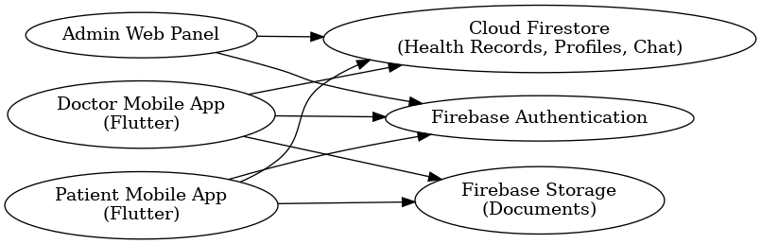
Figure 4.1.1 System Architecture

4.2 Data Representation
Data representation plays a critical role in how effectively doctors and patients can interact with the system. Each data component — whether a text note, vital reading, or message — is represented in a clear and structured format. Patient-entered health records are displayed chronologically, ensuring that both the patient and doctor can understand the progression of symptoms easily. Values such as blood pressure or heart rate are displayed with proper units, while symptoms and notes are shown in natural language to maintain clarity.
On the doctor’s side, the interface highlights the most recent entries to draw attention to the latest clinical information. Historical data is accessible but organized in sections for easy review, allowing doctors to quickly identify trends. Messages in the chat interface follow a readable bubble format, and timestamps are included automatically so that both users can interpret the conversation context. [7]
Because the system relies on manual entry, data validation is an important part of representation. The design ensures that invalid entries are prevented, and users receive helpful messages when corrections are needed. This ensures that the data doctors receive is meaningful, accurate, and clinically useful.

Patient Entity
- PatientID
- FullName
- Age
- PregnancyWeek
- Weight
- Email
- Phone
- MedicalHistory
- SubscribedDoctors (list)
Manual Health Entry Entity
- EntryID
- PatientID
- EntryType (HR, BP, Symptoms, Notes)
- Value
- Notes
- Timestamp
- Source = “manual”
Doctor Entity
- DoctorID
- FullName
- Specialization
- Email
- Phone
- Fee
- Experience/Ratings
Recommendation Entity
- RecommendationID
- DoctorID
- PatientID
- Message
- Timestamp

Chat Message Entity
- MessageID
- SenderID
- ReceiverID
- MessageText
- Timestamp
Data Flow Summary
- Patient enters data → App validates → Firebase stores → Doctor views.
- Patient subscribes → Link stored → Doctor gets access.
- Chat data saved → real-time syncing.
- Admin monitors all high-level operations.
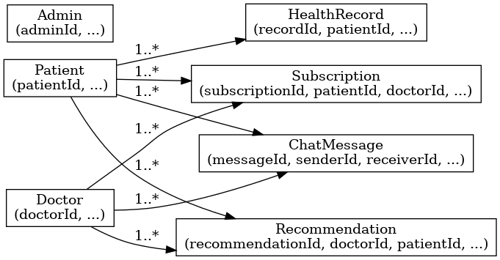
Figure 4.2.1 Data Representation/ERD

4.3 Process Flow / Representation
The process flow of the M2B system ensures a smooth journey from data entry to doctor feedback. When a patient enters new health information, the system immediately stores it in the backend and links it to the patient’s unique profile. This entry becomes instantly available to the subscribed doctor through real-time listeners. The doctor can review it at any time and send a recommendation or follow-up message as needed.
For doctor subscriptions, the process begins with the patient selecting a doctor from the available list. Upon confirmation, the system establishes a secure relationship between the patient and doctor profiles. From that moment onward, all patient updates are automatically accessible to the doctor. This process ensures that communication remains synchronized and that doctors have the complete context of the patient’s condition.
The chat module follows a similar workflow. Messages are sent through the interface, validated briefly, and then stored in the real-time database. Once received, they appear immediately on both ends of the conversation. This continuous flow enhances engagement and ensures timely medical support.
Manual Health Data Entry Flow
- Patient selects “Add Health Data.”
- App validates numeric and text fields.
- Valid data is sent to Firebase.
- Firebase stores as a new entry.
- Patient sees entry in history.
- Doctor can view entry if subscribed.
Doctor Recommendation Flow
- Doctor opens patient record.
- Views latest manual entries.
- Writes a recommendation.
- System stores recommendation.
- Patient receives a notification and can read it.
Subscription Flow
- Patient selects a doctor.
- Presses “Subscribe.”
- System processes subscription (local or API-based).
- Firebase updates user relationships.
- Doctor gains access to patient data.
Chat Flow
- User enters chat.
- Sends message.
- Firebase syncs it in real time.
- Receiver sees instantly.
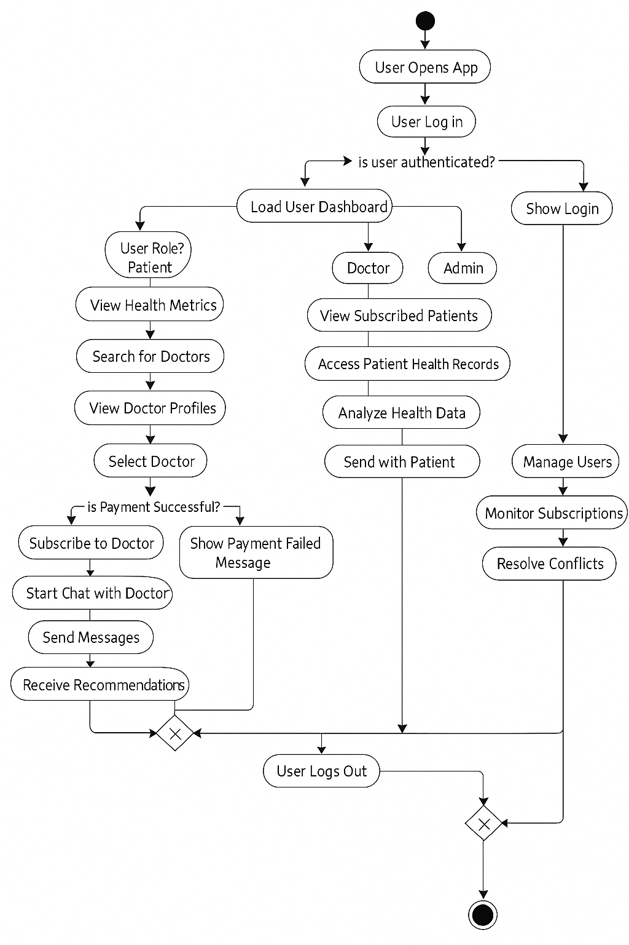
Figure 4.3.1 Process Flow

4.4 Design Models
Design models help visualize the internal structure and sequence of operations within the system. These models include use case diagrams, sequence diagrams, and architecture diagrams that illustrate the flow of information across modules. They serve as a communication tool between developers and stakeholders, ensuring everyone has a clear understanding of system behavior.
The design models also highlight the modular nature of the system. Instead of coupling all features together, the models demonstrate how each module—such as manual entry, subscription, chat, and recommendations—operates independently while still interacting through the backend. This modularity improves maintainability and future scalability. The design also accommodates potential expansions such as automated alert systems or integration with additional medical tools without requiring major changes to the existing workflow.

4.4.1 Use Case Model
Shows interactions between system actors and functionalities.
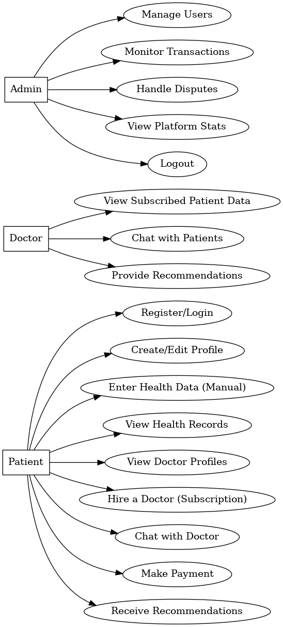
Figure 4.4.1 Use Case Diagram

4.4.2 Sequence Model
- Patient → App: enters health metrics
- App → Validator: checks input
- App → Firebase: uploads entry
- Firebase → App: success
- App → Patient: shows updated history
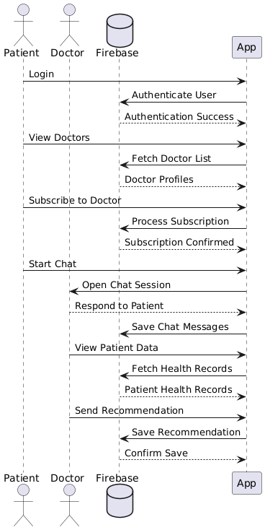
Figure 4.4.2 Sequence Diagram

4.4.3 Class Model
Main Classes
- Patient
- Doctor
- HealthEntry
- Recommendation
- Subscription
- ChatMessage
Each class contains attributes listed earlier.
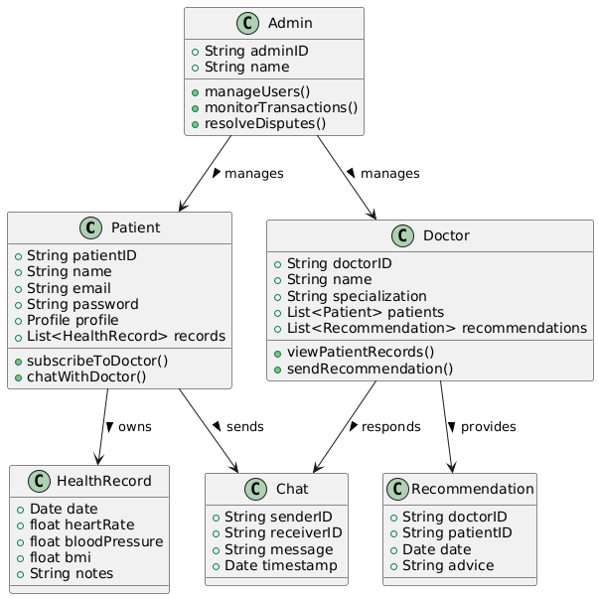
Figure 4.4.3 Class Diagram

4.4.4 Architectural Model
Follows client-server pattern:
Flutter app ↔ Firebase ↔ Admin Panel.
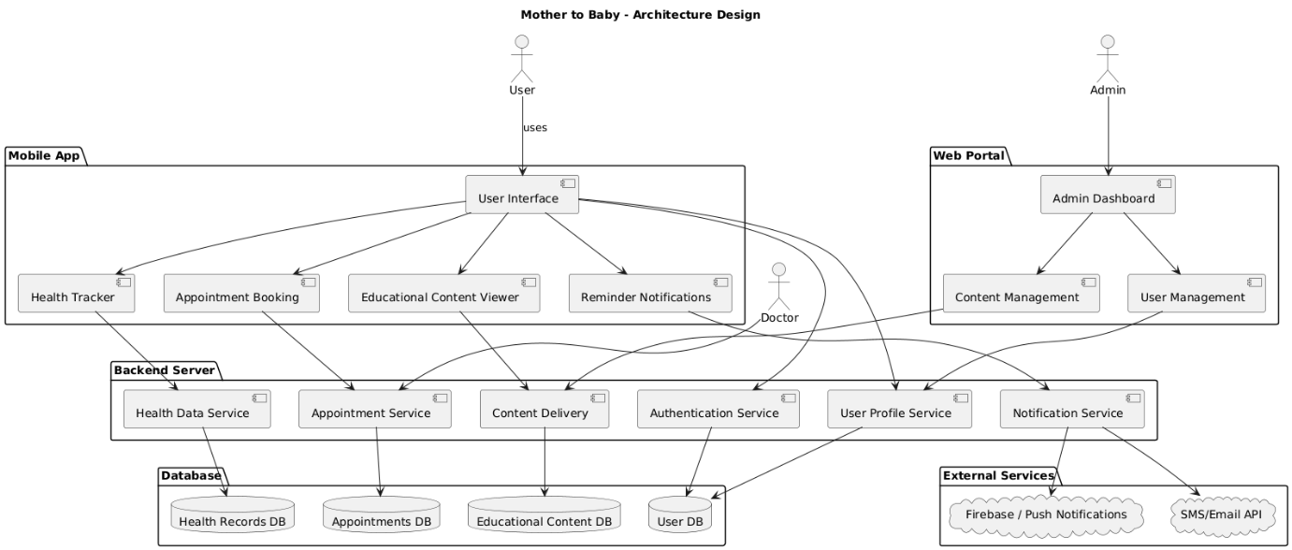
Figure 4.4.4 Architectural Model

Chapter 5
Implementation

5. Implementation
The implementation of the M2B system involved translating the conceptual designs into a practical, functional solution that supports seamless communication between pregnant women and healthcare professionals. Each feature was developed with special attention to usability, efficiency, and consistency. Since the primary users include pregnant women who may not always be familiar with technology, the system was built with simplicity in mind, ensuring that every interaction feels intuitive and predictable. The development process also focused on maintaining clean communication between the frontend interface and Firebase backend, ensuring data accuracy through all modules.
During implementation, a major emphasis was placed on making the system responsive across different screen sizes and devices. The app underwent several refinement cycles to ensure the navigation flow was simple, critical actions were easy to reach, and the user interface remained uncluttered. Multiple design decisions were taken to ensure that users experience minimal delays, clear feedback messages, and stable performance throughout the app, regardless of network conditions.

5.1 Implementation Overview
The implementation strategy followed an incremental approach where each module—such as authentication, manual health data entry, patient–doctor subscription, chat, and recommendations—was developed independently and later integrated into the final application. This allowed continuous testing and ensured that each module functioned correctly before moving on to the next. [8]
The patient interface was developed first, starting with account creation, login, and health data entry. Once the patient-side features were stable, the doctor’s application was developed to interpret and process the information sent by the patient. This included viewing health entries, responding with recommendations, and communicating through chat.
Throughout development, Firebase served as the central backend, managing secure authentication, real-time database updates, and data storage. Each data flow was thoroughly tested to ensure that when patients submitted information, it was immediately accessible to doctors. Similarly, the system ensured that doctor recommendations were delivered to patients without delay.
Patient Mobile Application
Handles manual health data entry, viewing history, searching for doctors, subscribing, chatting, and reading recommendations.
Doctor Mobile Application
Allows doctors to review subscribed patients, view manually entered health records, chat, and provide medical recommendations.
Firebase Backend
Manages authentication, data storage, real-time messaging, and cloud storage.

5.2 External APIs & Technologies Used
To ensure smooth functionality, the system integrates several external tools and libraries. Firebase Authentication was implemented to provide secure access for both patients and doctors. It manages user credentials, session handling, and secure login flows. Firestore served as the primary database, ensuring that all health entries and communications were stored efficiently and were easy to retrieve.
The Flutter framework played a vital role in creating a consistent and user-friendly interface. It allowed the development team to build dynamic layouts that adapt naturally to different screen sizes. Flutter’s pre-built UI components enabled smoother animations, interactive elements, and effective form validation.
Firebase Cloud Messaging (FCM) was used for real-time communication between doctors and women receiving prenatal care. It ensures that chat messages and recommendations are delivered instantly, creating a responsive experience similar to modern messaging applications.
Firebase Authentication

Used only for patient and doctor login/registration.
Handles
- Email & password login
- User identity management
- Secure session handling
Firebase Firestore / Realtime Database Stores:
- Patient profiles
- Doctor profiles
- Manual health entries
- Patient–doctor subscriptions
- Recommendations
- Chat messages
- The database is structured to efficiently retrieve patient timelines and doctor dashboards.
Firebase Cloud Messaging
Supports:
- Real-time chat messaging
- Instant data updates
Firebase Storage
Used If doctors upload any supplementary files, such as notes or images.
Flutter Framework
Used to build both the patient and doctor apps with:
- Material design widgets
- Navigation
- Validation
- State management
- Integration with Firebase SDK

5.3 Patient Application Implementation
The patient-side app was built with a design philosophy focused on reducing stress and increasing ease of use. Since pregnant women may use the app under different emotional and physical states, all essential features were placed within easy reach, and navigation was kept minimal.
Data entry screens include clearly labeled fields, supportive placeholders, and error messages that guide users toward correct input. Each entry undergoes validation before being saved to ensure no incorrect data is stored. Feedback messages confirm successful submissions, reducing confusion and helping build user confidence.
In addition to data entry, patients can search for doctors based on their displayed specialties and qualifications. The doctor profiles provide enough information for women to feel confident in selecting the right healthcare provider. The subscription process is straightforward and ensures that once a doctor is selected, all relevant patient entries become accessible to that doctor.
The chat interface is designed to resemble familiar messaging apps. A simple message box, clean display bubbles, and instant updates make communication intuitive and reliable. This helps patients feel heard and supported without needing to visit a clinic for every concern.

5.3.1 Login & Registration
- Patient enters email and password.
- Firebase Authentication checks validity.
- Correct credentials take the patient to the dashboard.
- Errors such as invalid email or wrong password trigger validation messages.
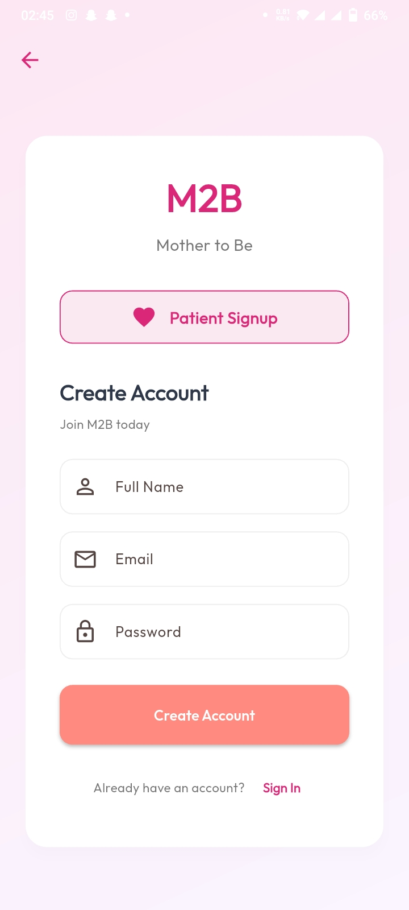
Figure 5.3.1 Registration Screen
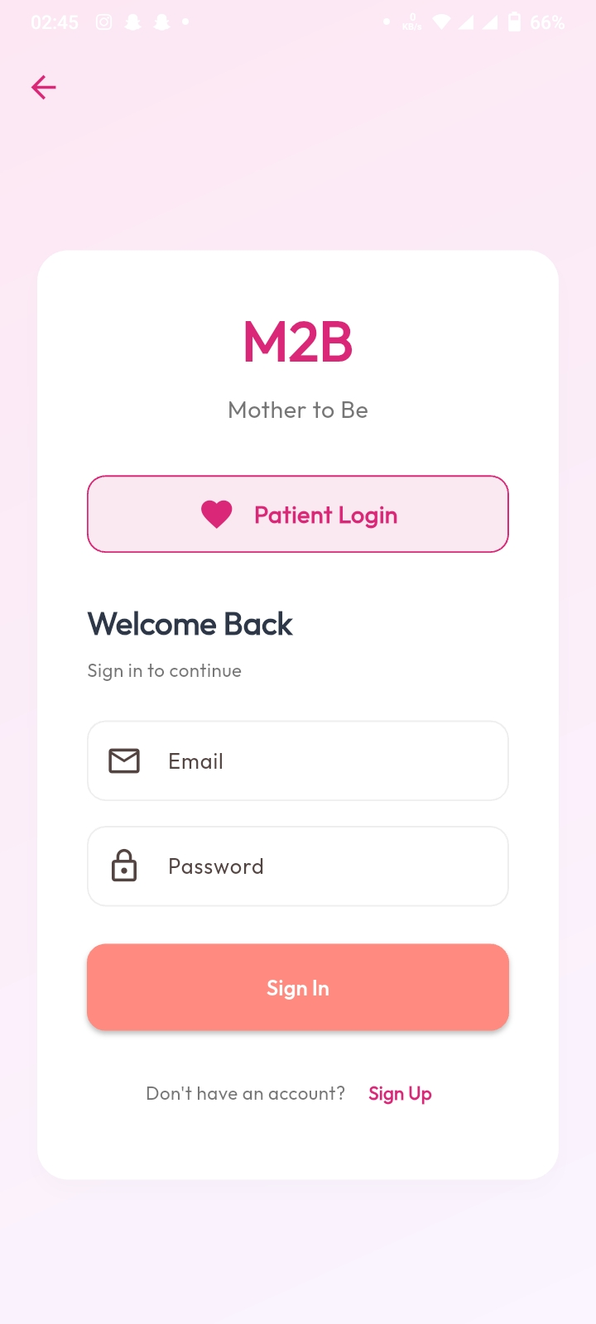
Figure 5.3.2 Login Screen

5.3.2 Manual Health Data Entry
This is the core of the system. Patients manually enter:
- Heart Rate
- Blood Pressure
- Symptoms
- Weight
- Notes
Implementation details:
- Input fields validate numeric and text values.
- Timestamps are generated automatically.
- Data is saved in Firestore under the patient’s entry log.
- Each entry is stored with metadata: type, value, notes, timestamp.
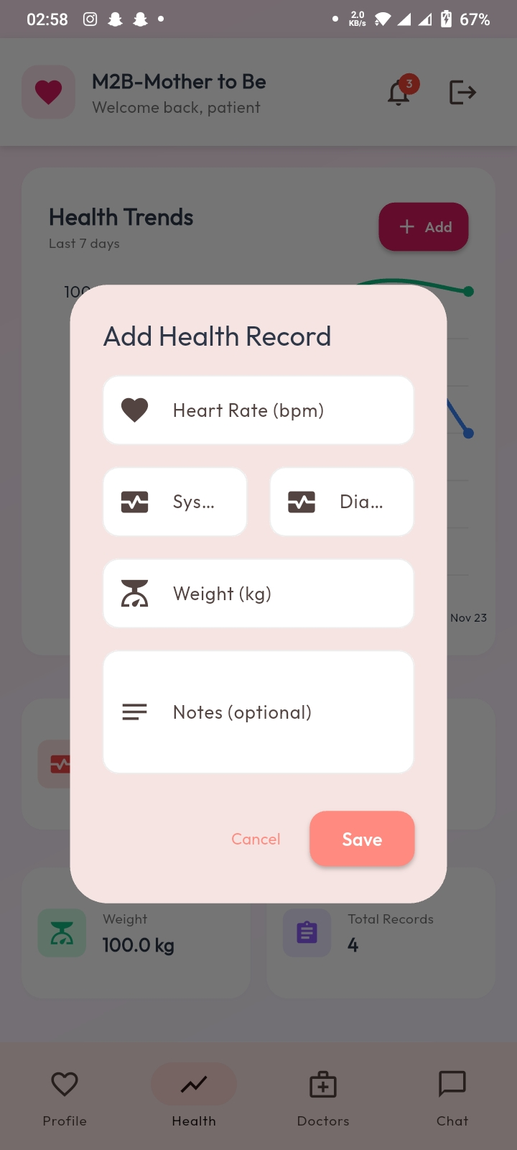
Figure 5.3.3 Manual Health Data Entry

5.3.3 Health History View
All manual entries are shown in a chronological list.
The implementation:
- Firestore queries all entries for that patient.
- Entries are sorted by timestamp in descending order.
- The UI shows each entry in a card layout.
- Filters allow viewing specific types (e.g., only BP or only symptoms).
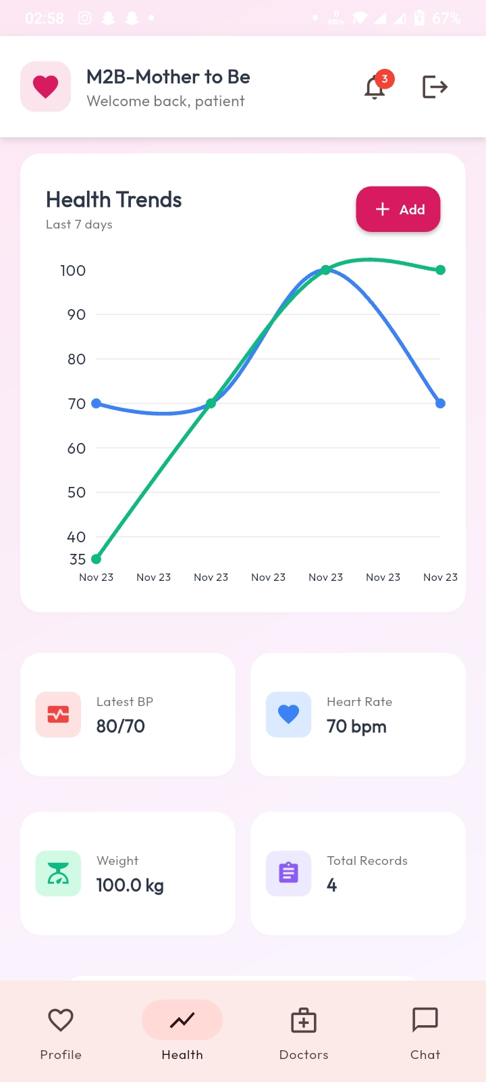
Figure 5.3.4 Health History View
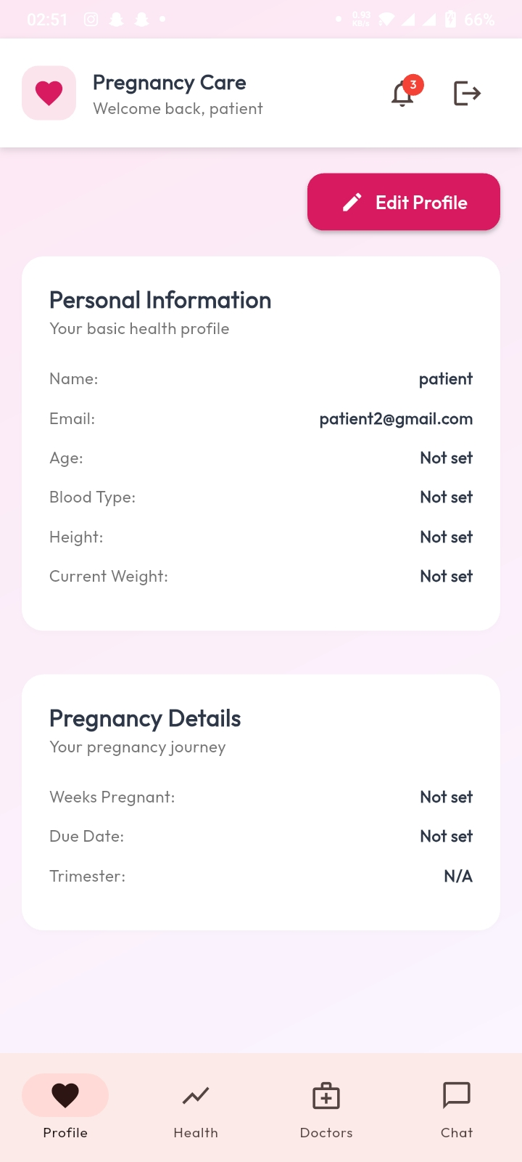
Figure 5.3.5 Health History Review
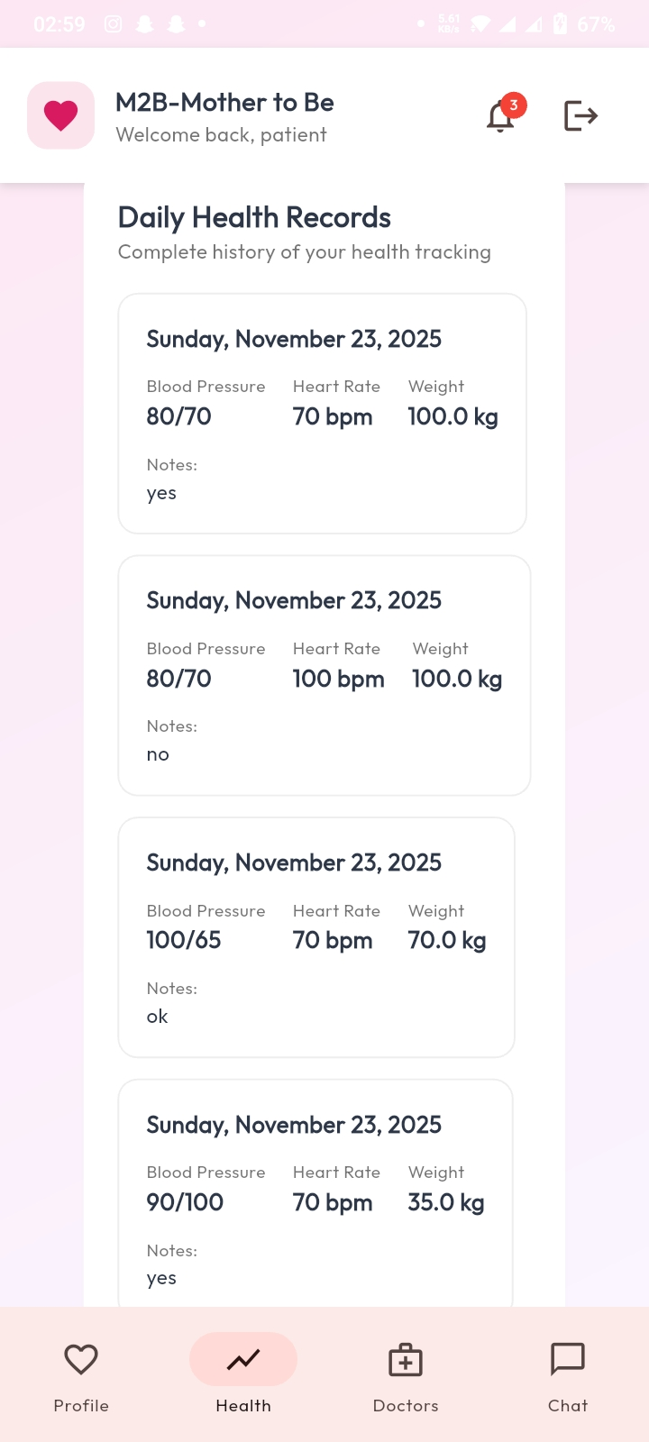
Figure 5.3.6 Health History View

5.3.4 Doctor Search and View
Patients can browse available doctors.
- The list is fetched from Firestore.
- Each doctor profile displays specialization, qualification, fee, and experience.
- Patients can open a detailed profile for more information.
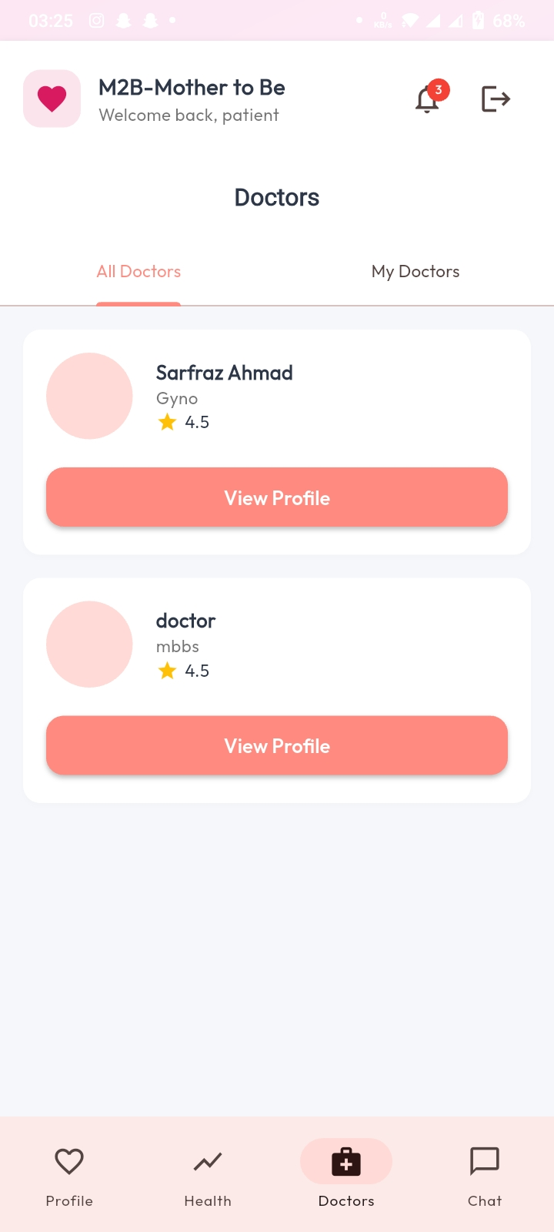
Figure 5.3.7 Doctor Search & View

5.3.5 Subscription System
- When a patient subscribes to a doctor, a link is created in Firestore.
- Doctors only see patients who subscribed to them.
- The subscribed doctor relationship is stored as a document containing patient ID and doctor ID.
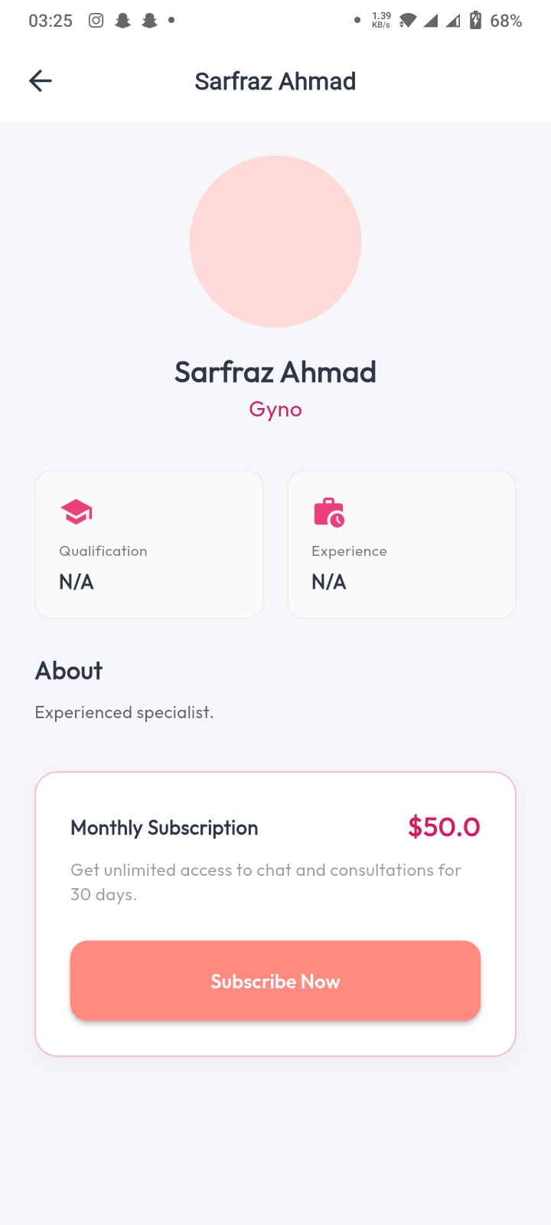
Figure 5.3.8 Subscription Screen

5.3.6 Chat Module
Chat uses:
- Firebase Realtime Database or Firestore listeners
- Instant message rendering
- Timestamps for each message
The chat screen:
- Loads all previous messages
- Displays them in bubble format
- Sends new messages instantly
- Updates automatically when the other user replies
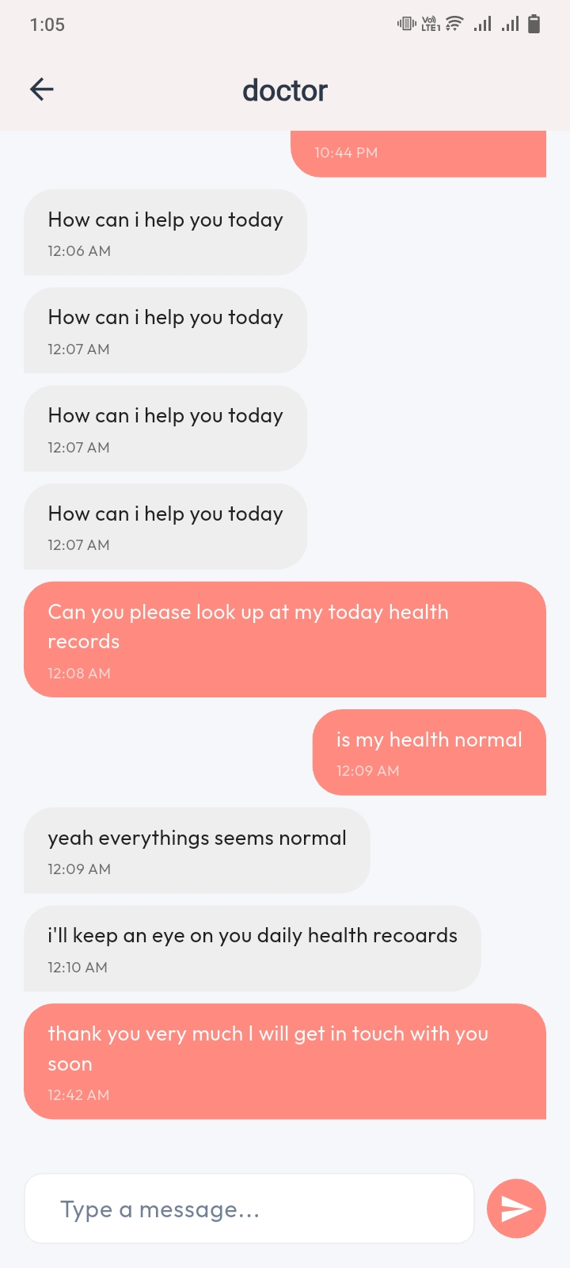
Figure 5.3.9 Chat Module

5.4 Doctor Application Implementation
The doctor-side implementation focuses on efficiency and readability. Healthcare professionals often have limited time, so the app prioritizes the most important information and minimizes unnecessary steps. Doctors can quickly view a list of subscribed patients and immediately access their recent health entries.
Each patient’s health timeline is organized in a clear, chronological format. Readings such as blood pressure or heart rate are displayed alongside symptoms and notes, giving the doctor a complete picture of the mother’s condition. This organized structure helps doctors identify unusual patterns and respond promptly.
The recommendation feature allows doctors to provide observations and guidance in a structured way. Messages appear in the patient interface as soon as they are submitted. This enables doctors to influence patient behavior remotely and intervene when necessary. The chat module further enhances communication, allowing quick clarifications or follow-up questions.
The doctor app also focuses on clarity. The interface avoids overwhelming screens and instead organizes information in sections, allowing doctors to efficiently navigate between patients and respond to each case accurately. [9]

5.4.1 Doctor Login & Profile Setup
Doctors:
- Register using Firebase Authentication
- Add specialization, experience, fee, and biography
- Update their profile anytime
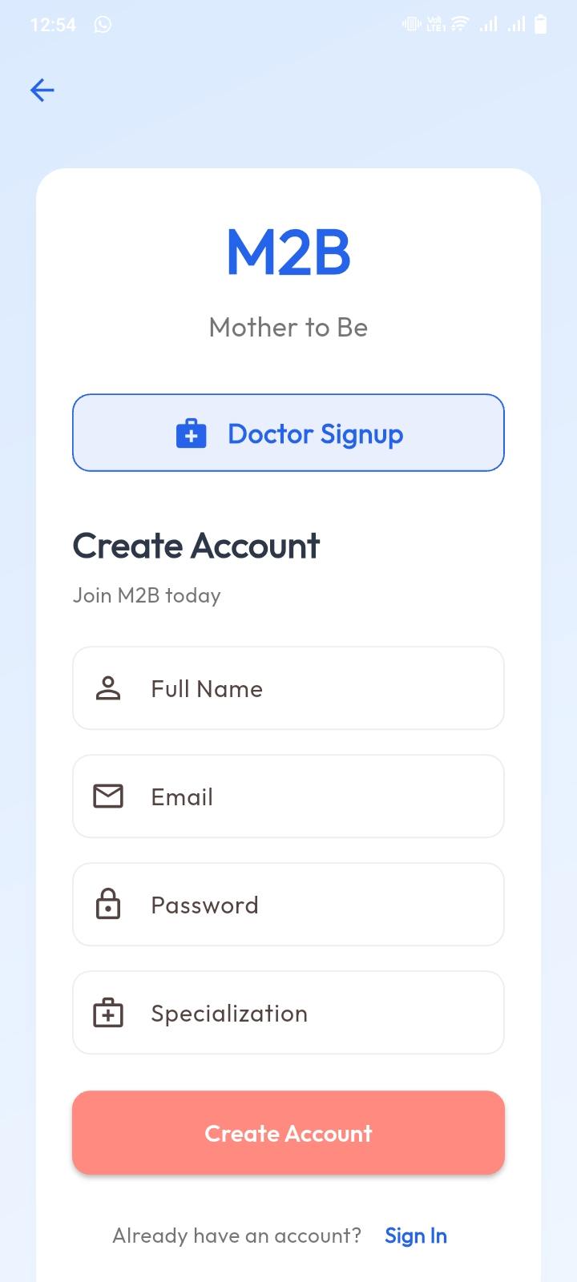
Figure 5.3.10 Doctor Signup Screen
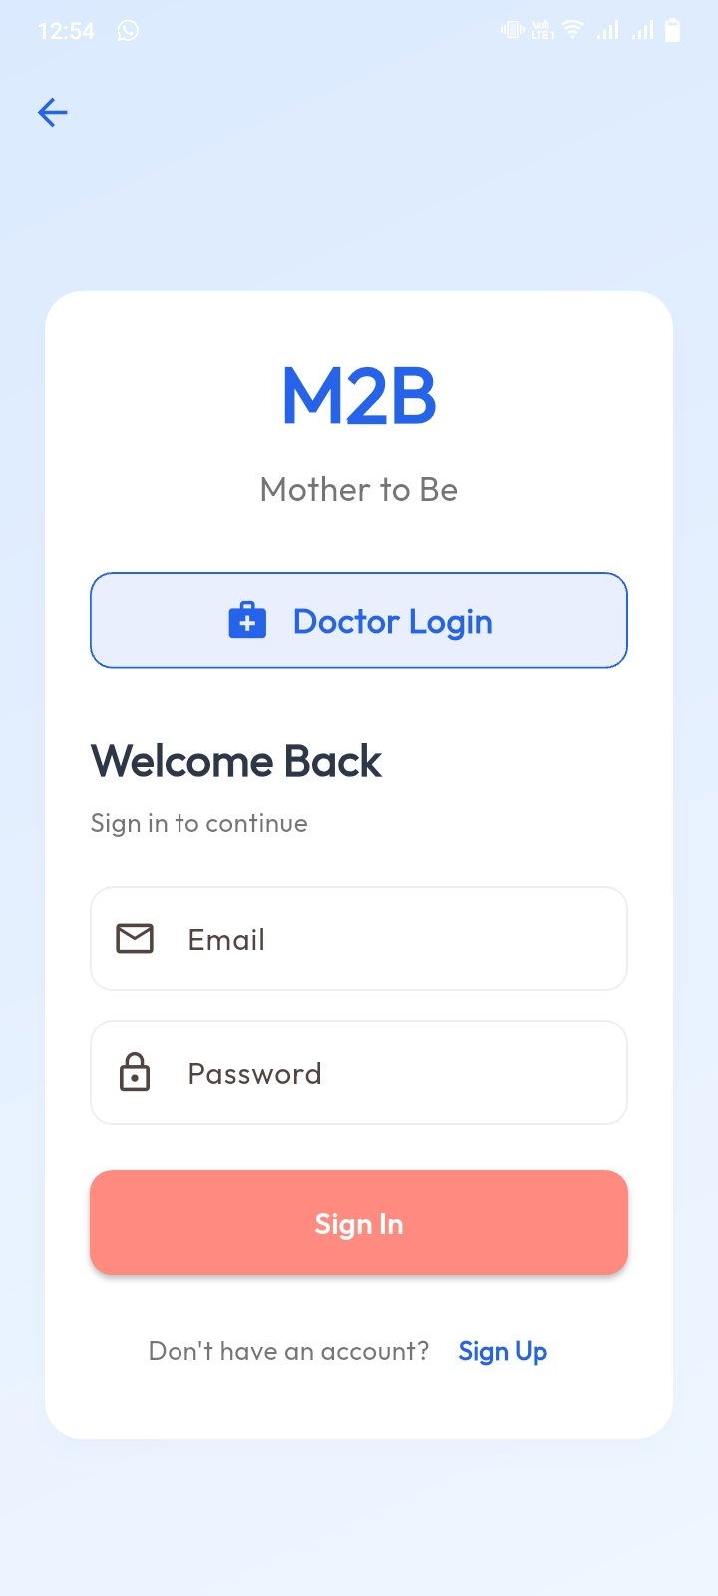
Figure 5.3.11 Doctor Login Screen

5.4.2 Subscribed Patient List
After a patient subscribes:
- The doctor app retrieves those patients from Firestore
- A list appears with name and basic information
- Each patient can be selected for deeper review
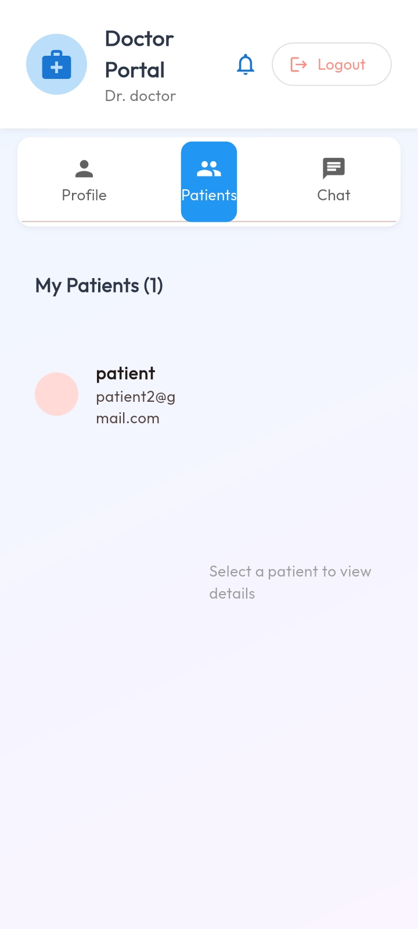
Figure 5.3.12 Subscribed Patient Lists

5.4.3 Viewing Manual Health Data
Doctors can view all manual entries entered by a patient, including:
- Heart rate logs
- BP readings
- Symptoms list
- Daily notes
The Implementation:
- Firestore query retrieves all entries for that specific patient
- Data is shown in a timeline or list format
- Doctors can analyze trends based on timestamps
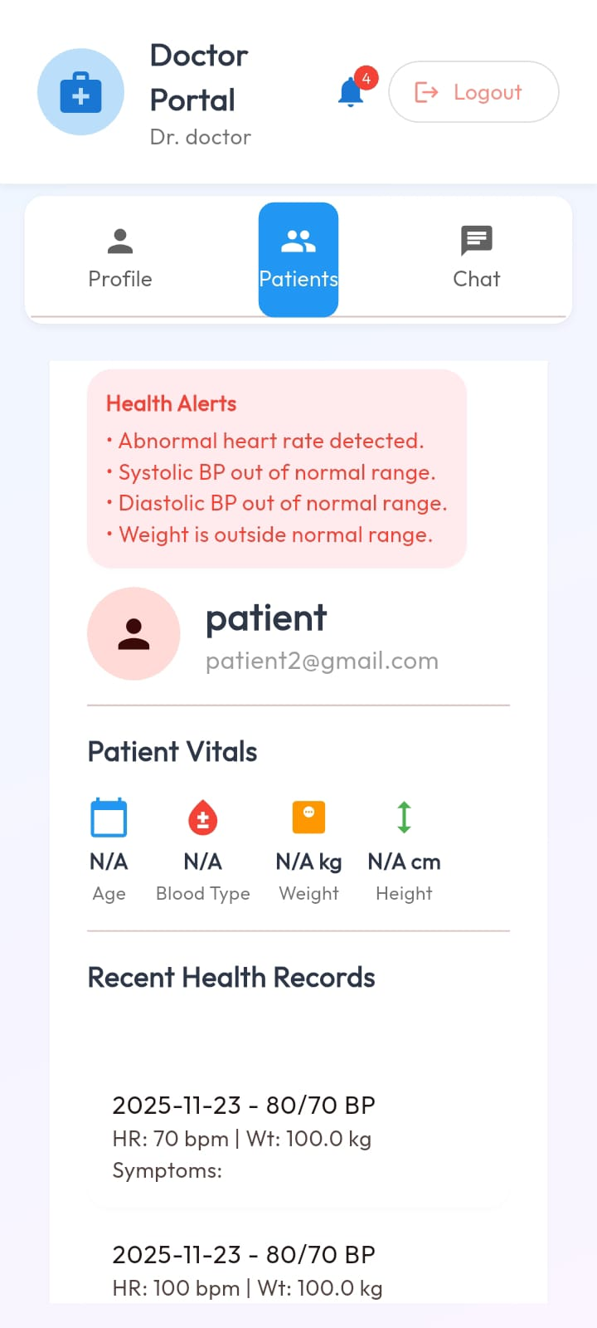
Figure 5.3.13 Manual Health Data

5.4.4 Writing Recommendations
The doctor app includes a simple recommendation form.
Doctors enter:
- Advice text
- Observations
- Prescriptions (optional)
The system:
- Stores recommendations in Firestore
- Sends instant updates to the patient’s app

5.4.5 Chat Module
The chat system is fully replicated for doctors.
- Messages are synced in real-time
- Doctors can view full conversation history
- All messages are stored securely in Firestore/Realtime Database
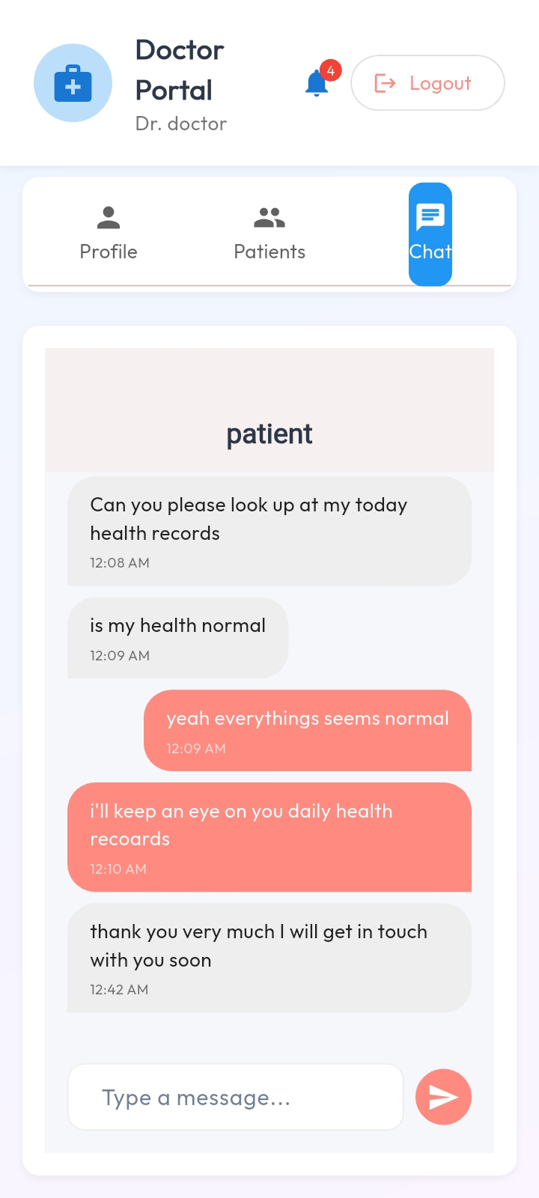
Figure 5.3.14 Chat Module

5.5 User Interface Design
The user interface was designed to be visually calm, simple, and easy to understand. Colors, font sizes, spacing, and touch targets were selected with pregnant women in mind. Buttons are large and clear, text is readable, and screens avoid unnecessary visual clutter.
On the patient side, forms are structured so users can enter information quickly with minimal effort. The history view uses clean cards or simple lists that display essential information at a glance. The goal was to reduce cognitive load and ensure a stress-free user experience.
On the doctor side, clarity and readability take priority. Patient data is organized by date and category, making it easy for doctors to scan through information and make accurate decisions. Chat screens follow a familiar layout to minimize learning time.
Across the entire system, consistency is maintained to ensure that users quickly learn how to interact with the application, regardless of which screen they are using. Smooth transitions, responsive touch interactions, and minimal technical complexity contribute to a reliable and pleasant user experience.
Patient UI
- Clean, soft colors suitable for pregnant women
- Large text and icons
- Forms optimized for quick manual entry
- Easy navigation tabs
- A responsive chat interface
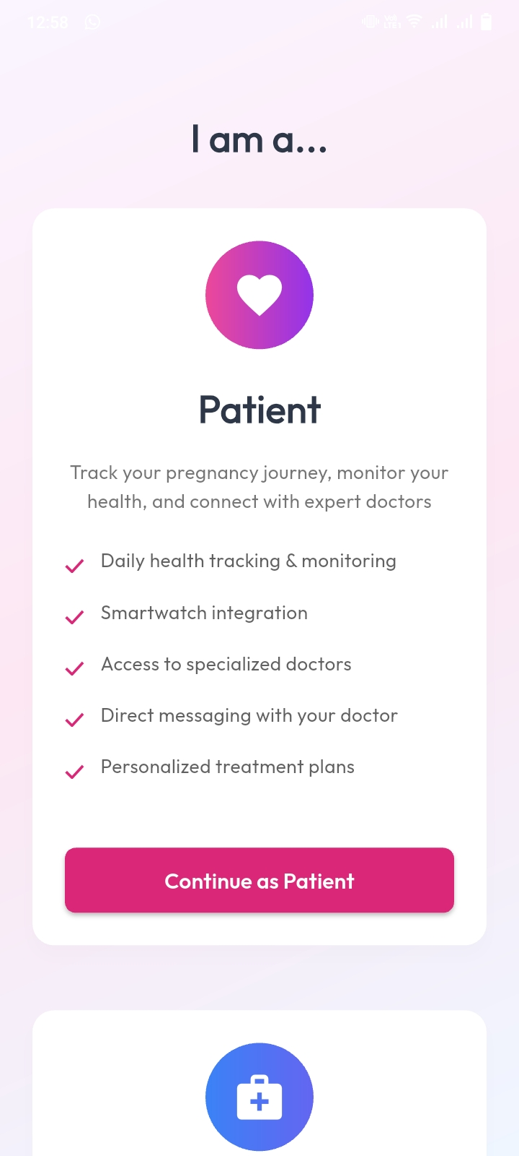
Figure 5.3.15 Patient UI
Doctor UI
- Professional and clean dashboard
- Organized patient list
- Clear manual entry viewer
- Simple form for recommendations
- Real-time chat interface
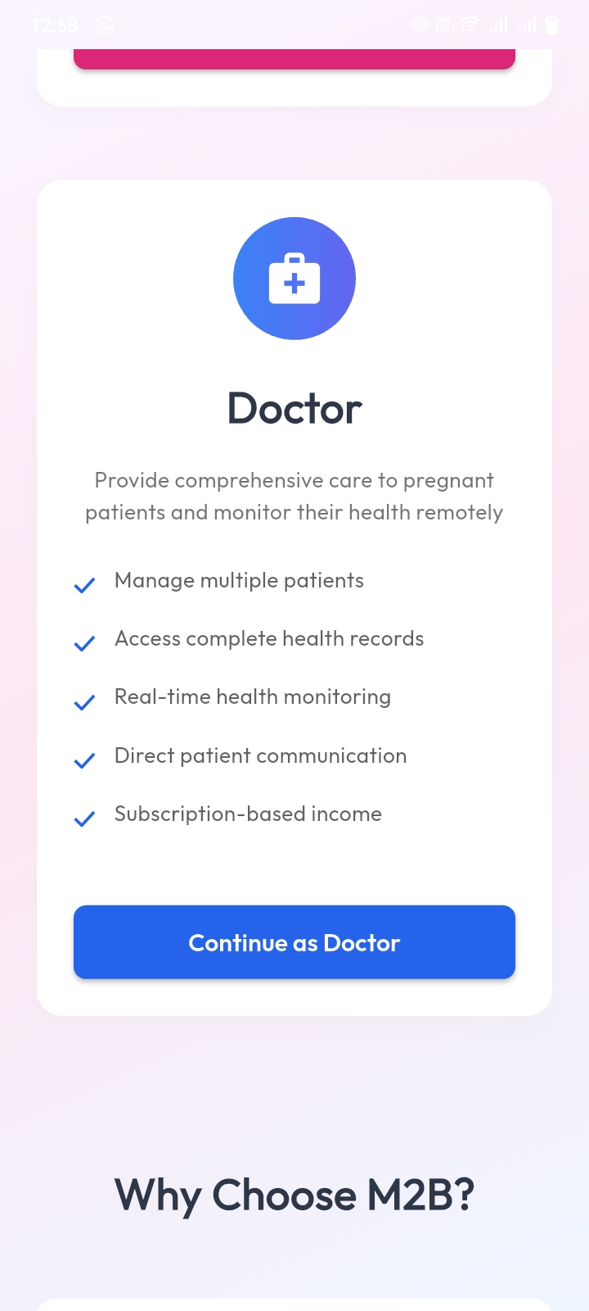
Figure 5.3.16 Doctor UI

Table 10 External APIs
API Name | Description | Purpose in Project | Used In Module
Firebase Authentication API | Firebase Authentication API | Firebase Authentication API | Firebase Authentication API
Firebase Fire store / Realtime DB API | Firebase Fire store / Realtime DB API | Firebase Fire store / Realtime DB API | Firebase Fire store / Realtime DB API
Firebase Cloud Storage API | Firebase Cloud Storage API | Firebase Cloud Storage API | Firebase Cloud Storage API
Firebase Cloud Messaging (FCM) | Firebase Cloud Messaging (FCM) | Firebase Cloud Messaging (FCM) | Firebase Cloud Messaging (FCM)
Flutter Framework APIs | Flutter Framework APIs | Flutter Framework APIs | Flutter Framework APIs
Payment/Subscription API (Local or external) | Payment/Subscription API (Local or external) | Payment/Subscription API (Local or external) | Payment/Subscription API (Local or external)

Chapter 6
Testing and Evaluation

6. Testing and Evaluation
Testing and evaluation were essential to confirm that the M2B system performs reliably across all its features and behaves correctly in both normal and exceptional conditions. Since the system directly supports maternal health monitoring, accuracy, stability, and ease of use were top priorities throughout the testing phase. The testing approach combined manual and automated techniques to verify functionality, usability, performance, and data integrity.
The system was continuously tested during development to ensure that each module—data entry, doctor subscription, chat, and recommendations—worked independently before being integrated into the final solution. This method allowed early detection of logical errors, UI issues, and data synchronization problems. By the final stage, all components worked cohesively, ensuring a seamless user experience for both pregnant women and doctors.
This presents the testing methodology, test cases, results, and evaluation of the M2B (Mother to Baby) prenatal health monitoring system. The primary purpose of testing is to ensure that every module functions correctly, meets the requirements, and behaves reliably under different conditions.
Testing is divided into:
- Manual Testing
- System Testing
- Unit Testing
- Functional Testing
- Integration Testing
- Automated Testing

6.1 Manual Testing
Manual testing was carried out during each development stage to verify that every function behaves correctly. Each module was executed multiple times to confirm that user inputs, navigation flows, and interactions with Firebase produced the expected results.
During manual testing, the login screens, registration forms, manual health data entry process, chat system, doctor search module, and subscription workflow were tested thoroughly by interacting with the actual mobile application. Errors such as incorrect input values, empty fields, or invalid email formats were intentionally introduced to observe whether the system responded with the appropriate validation messages. The app consistently displayed correct warnings and prevented invalid submissions.

6.1.1 System Testing
System testing was performed to ensure that the entire M2B system, as a complete product, behaved according to the defined requirements. The goal was to ensure that the system’s functionalities integrated properly and worked as a whole. [10]
During system testing, the login module was tested using correct and incorrect credentials to verify proper authentication. The manual health data entry module was tested by entering valid and invalid data to ensure proper validation and successful storage. The doctor search module was tested to confirm that lists of available doctors loaded correctly. The chat system was tested for real-time message exchange, and it successfully displayed messages instantly between patient and doctor. All system-level tests produced the expected outcomes.
Test Case / Test Script | Attribute & Value | Expected Result | Result
Verify system stability after login | – | System loads dashboard without crash | Pass
Verify navigation between major modules | – | All screens open smoothly without errors | Pass
Table 11 System Testing

6.1.2 Unit Testing
Unit testing focused on individual components of the app, such as screens, functions, and validation blocks.
The login unit test involved entering empty fields and incorrect passwords to check whether the system produced the correct error messages. For the manual data entry unit test, invalid values (such as negative numbers or impossible vital signs) were entered to ensure that validation prevented submission. When valid data was entered, it was accepted without any issue and saved properly in Firebase. These unit tests confirmed that every small component worked exactly as intended.
Test Case / Test Script | Attribute & Value | Expected Result | Result
Login with valid credentials | Email, Password | User successfully logs in | Pass
Login with invalid credentials | Wrong password | Error message displayed | Pass
Add new health entry | HR, BP, Symptoms | Entry saved with timestamp | Pass
Validation on empty fields | No input | Form shows validation errors | Pass
Update profile information | Name, Email | Profile updated successfully | Pass
Logout user | – | User session cleared | Pass
Table 12 Unit Testing

6.1.3 Functional Testing
Different user roles (Patient, Doctor) were tested by logging in with different role credentials. The system correctly displayed role-based dashboards. The subscription process was checked by subscribing a patient to a doctor, after which the doctor gained immediate access to the patient’s health records. The doctor recommendation feature was tested by having a doctor send advice, which appeared instantly in the patient’s app. All functional requirements were satisfied without errors.

Test Case / Test Script | Attribute & Value | Expected Result | Result
Search doctors | Keyword input | Doctor list displayed | Pass
View doctor profile | Selected doctor | Profile loaded successfully | Pass
Subscribe to doctor | Valid subscription | Patient linked to doctor | Pass
Manual health data entry | HR, BP, Symptoms | Data validated and saved | Pass
View health records | – | Records displayed chronologically | Pass
Send chat message | Text message | Message delivered instantly | Pass
Receive doctor recommendation | Text input | Recommendation visible to patient | Pass
Table 13 Functional Testing

6.1.4 Integration Testing
Integration testing was performed to verify that combined modules worked correctly when interacting with one another. The patient–doctor subscription flow was tested by connecting a patient to a doctor and then confirming that the doctor could view the patient’s manual health entries. The chat system and recommendation features were tested together to ensure they operated smoothly after subscription was established. Additionally, when the patient entered new health data, the doctor immediately saw the updated records, proving that the health data module and doctor module integrated successfully. The interaction between Firebase Authentication, Firestore Database, and the mobile app also performed without issues.

Test Case / Test Script | Attribute & Value | Expected Result | Result
Health entry → doctor panel sync | HR/BP values | Entry appears on doctor dashboard | Pass
Doctor recommendation → patient | Text message | Notification + recommendation shown | Pass
Patient–doctor chat real-time sync | Messages | Messages appear instantly on both sides | Pass
Subscription linking | Patient & doctor IDs | Doctor gains access to patient data | Pass
Profile update sync | Name/Email | Updated info visible across modules | Pass
Table 14 Integration Testing

6.2 Automated Testing
Automated testing was performed using Flutter’s built-in testing framework and Firebase Emulator Suite. These tools checked data validation, backend connectivity, and code correctness without requiring manual interaction.
The Flutter test environment verified UI components, ensuring that widgets behaved correctly and navigation routes were error-free. Firebase Emulator Suite tested authentication flows, database reads/writes, and security rules in a controlled local environment, confirming that no unauthorized access was possible. The Dart Analyzer tool was also used to scan for syntax errors, unused imports, and coding standard issues. All automated tests passed successfully, confirming code stability and backend reliability.

Tool Name | Tool Description | Applied On | Results
Flutter Test | Unit testing for Flutter components | Input validation, controllers | Pass
Firebase Emulator Suite | Local simulation of Firestore & Auth | Authentication, database operations | Pass
Dart Analyzer | Static code analysis | Warnings, errors, formatting | Clean
Table 15 Automated Testing

Tools Used
During the testing and evaluation of the M2B (Mother to Baby) system, several tools were used to validate functionality, performance, and backend reliability.
The Flutter Testing Framework was utilized to test UI widgets, screen navigation, and form validation. It ensured that each interface behaved correctly and responded properly to user input.
The Firebase Emulator Suite was used to test authentication, Firestore database operations, and data security rules in a safe, local environment. This allowed the system to be evaluated without affecting live data and helped identify issues related to data storage and permission handling.
To maintain code quality, the Dart Analyzer tool was used. It automatically detected syntax errors, unused code, and formatting issues, helping keep the application stable and well-structured.
For real-time communication testing, Firebase Cloud Messaging (FCM) tools were used to verify chat responsiveness and notification delivery. This ensured that patient–doctor messaging worked smoothly under different network conditions.
Debugging tools provided by Android Studio and Visual Studio Code were also used. These helped monitor logs, track errors, and test the application on various virtual and physical devices.
Together, these tools reinforced the reliability, stability, and overall performance of the M2B system during the testing phase.

Chapter 7
Conclusion and Future Work

7. Conclusion and Future Work
This concludes the development of the M2B (Mother to Baby) prenatal health monitoring system and presents potential future enhancements. It reflects on how the system fulfills its intended purpose and the value it contributes to both patients and doctors.

7.1 Conclusion
The M2B (Mother to Baby) system successfully addresses the need for a reliable, easy-to-use, and accessible prenatal health monitoring solution, especially for pregnant women who face difficulties in visiting hospitals frequently or maintaining consistent medical records. The system replaces expensive wearable-based monitoring approaches with a simpler and more inclusive model, manual health data entry supported by direct doctor consultation.
Throughout the development process, the system was carefully designed and implemented according to the functional and non-functional requirements outlined in the SRS. The use of Flutter for the mobile interface and Firebase for backend services ensured a secure, scalable, and real-time environment for patients, doctors, and administrators.
The system enables patients to manually record their health metrics such as heart rate, blood pressure, symptoms, and daily notes. Doctors can view these entries only after the patient subscribes to them, ensuring privacy and controlled access. The inclusion of real-time chat further improves patient–doctor communication, enabling timely medical advice. The admin panel supports system oversight, user management, and subscription monitoring.
Testing and evaluation confirmed that all modules—authentication, manual data entry, doctor subscription, chat, recommendations, and admin monitoring—work consistently and accurately. The system operates smoothly and fulfills its intended purpose of improving prenatal care accessibility, communication, and health tracking.
In conclusion, M2B provides a meaningful digital health solution that empowers pregnant women and enhances doctor engagement without relying on expensive hardware or complex devices. It is a user-friendly, cost-effective, and medically supportive platform that can be adopted widely.

7.2 Future Work
While the current version of M2B fulfills its core objectives, several enhancements can further improve its usability, accuracy, and impact. One important area for future development is the addition of automated health-risk alerts. By analyzing patient-entered data patterns, the system could notify both the doctor and the patient when values cross specific thresholds, helping identify high-risk conditions earlier.
Support for multimedia entries, such as allowing patients to upload images related to symptoms or medication, could provide doctors with more context during evaluations. Integrating educational content, such as trimester-based guidance or medically verified articles, would also help increase awareness and improve patient knowledge.
Another future direction is the introduction of multilingual support to make the system more accessible to women from diverse cultural and linguistic backgrounds. Expanding the platform to include voice input for women who are uncomfortable typing could further enhance usability.
From a technical perspective, predictive analytics and machine learning models could be incorporated to identify trends and forecast potential complications. As the system grows, integrating appointment scheduling with hospitals or clinics may further streamline communication and improve continuity of care.
Overall, the system has strong potential for expansion into a more comprehensive maternal health platform, serving as a digital companion throughout pregnancy and beyond.
Integration with External Medical Devices
Although the current version uses manual entry, future versions could optionally integrate:
- Bluetooth-enabled blood pressure monitors
- Body temperature sensors
- Weight scales
These would automate some entries while still keeping the app accessible to all.

AI-Based Health Risk Predictions
Machine learning can be integrated to:
- Predict possible complications (e.g., gestational hypertension)
- Analyze trends in manual entries
- Provide early warnings to doctors and patients
Video Consultation
Adding audio/video call functionality would:
- Allow remote checkups
- Improve doctor–patient communication
- Support emergency or urgent consultations
Appointment Booking and Scheduling
A built-in calendar system can enable:
- Booking follow-up checkups
- Reminders for upcoming appointments
- Auto-scheduling with doctors’ availability
Multi-language Support
Multiple language options (Urdu, Punjabi, Sindhi, Pashto, etc.) would allow:
- Higher accessibility across Pakistan
- Ease of use for rural populations

Pregnancy Education Module
Adding educational content such as:
- Daily tips
- Diet guidelines
- Exercise recommendations
- Week-by-week fetal development updates
This would turn the system into a complete prenatal health assistant.
Emergency Alert System
A panic or emergency button could:
- Alert the doctor immediately
- Share patient’s last health readings
- Notify a saved emergency contact
Pharmacy Integration
Future versions may allow:
- Ordering prescribed medicine online
- Storing digital prescriptions
- Viewing nearest pharmacies
Offline Data Entry with Later Sync
Allow patients to enter data offline and sync when internet becomes available.
Doctor Dashboard Analytics
More advanced doctor tools can be added such as:
- Trend graphs
- Risk scoring
- Bulk recommendations

Chapter 8
References

8. References
This contains all the references used throughout the research, analysis, design, and implementation of the M2B (Mother to Be) prenatal monitoring and consultation system. All references follow the format style shown in your provided project template (journal articles, books, and websites).

References

[1] | R. S. Pressman, Software Engineering: A Practitioner’s Approach, New York: McGraw-Hill, 2010.
[2] | I. Sommerville, Software Engineering, London: Pearson, 2015.
[3] | A. Behforooz and F. J. Hudson, Software Engineering Fundamentals, Oxford: Oxford University Press, 1996.
[4] | B. Shneiderman and C. Plaisant, Designing the User Interface, Boston: Pearson, 2017.
[5] | S. Koivunen, "Mobile Health Applications in Prenatal Care: User Engagement Analysis," Journal of Mobile Health, p. 12–20, 2020.
[6] | F. Ngabo and e. al., "Designing and Implementing an Innovative SMS-Based Maternal Health System," BMC Pregnancy and Childbirth, pp. 1-10, 2012.
[7] | H. Chen and e. al., "Real-Time Health Monitoring Using Mobile Applications: A Review," Journal of Medical Systems, pp. 1-12, 2019.
[8] | G. Firebase, "Firebase Documentation," 2024. [Online]. Available: https://firebase.google.com.
[9] | G. F. Team, "Flutter Documentation," 2024. [Online]. Available: https://docs.flutter.dev.
[10] | W. H. Organization, "Maternal Health Overview," 2024. [Online]. Available: https://www.who.int/health-topics/maternal-health.

